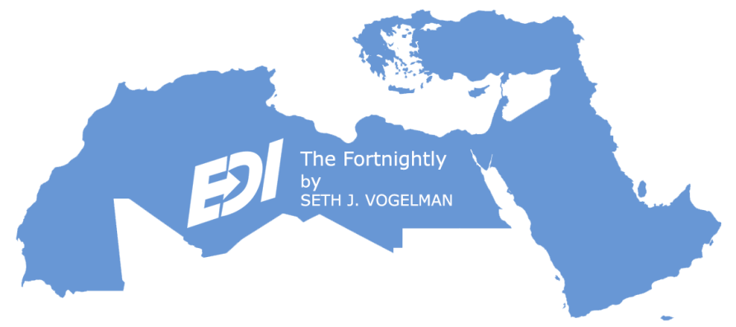
The FORTNIGHTLY
A Review of Middle East Regional Economic & Cultural News & Developments
21 June 2023
2 Tammuz 5783
3 Dhul Hijjah 1444

Written & Edited by Seth J. Vogelman*

TABLE OF CONTENTS
1. ISRAEL GOVERNMENT ACTIONS & STATEMENTS
1.1. Israel's Speaker of the Knesset Pays First Visit to Morocco
1.2. Israel Promotes EastMed Undersea Electricity Cable Connecting With Europe
1.3. Intel to Upgrade its New Kiryat Gat Fab with a $15 Billion Investment
1.4. Israel & Cyprus Discuss the Status of the Aphrodite Gas Reservoir
1.5. Israel to Work with Egypt and Palestinian Authority to Develop Gaza Gas Field
2. ISRAEL MARKET & BUSINESS NEWS
2.1. ScoutCam Announces Corporate Rebranding and Changes Name to Odysight.ai
2.2. Lightico Acquires Vizolution as Demand Booms for Digital Customer Completion
2.3. FICC Signs Agreements with Alberta
2.4. Toshiba Digital Solutions & Classiq Collaborate on Gate-Based Quantum Computing
2.5. H2O Innovation Secures Large Orders and Breaks into Israeli Market
2.6. Percepto Raises $67 Million Series C Round & Receives FAA Waiver
2.7. Kodem Raises $18 Million in a Series A Funding Round
2.8. Uber to Exit Israel as its Market Share Disappoints
3. REGIONAL PRIVATE SECTOR NEWS
3.1. Elevai Labs Expands Internationally with Central Circle Company in Kuwait
3.2. Canada’s Arms Exports Burgeon to Saudi Arabia, Israel & Qatar
3.3. Chinese Biotech Companies Making Inroads in the Middle East
3.4. Canada’s Brookfield Acquires Network International for $2.8 Billion
3.5. VPORTS Starts Certification Process for Vertiports
3.6. Snow Abu Dhabi Opens its Doors
3.7. Burjeel Holdings & Northwell Health to Launch Neuroscience Institute in UAE
3.8. Autobia Raises $2.5 Million Seed Round
3.9. COFE Digitizes the Coffee Experience from Bean to Cup
3.10. Arqit and DETASAD Announce Strategic Teaming Agreement
3.11. Trella Raises $3.5 Million from Avanz Capital
3.12. Abu Dhabi's G42 and Israel's Viola Partner up in New Tech Venture
4. CLEAN TECH & ENVIRONMENTAL DEVELOPMENTS
4.1. Israel's Biggest Renewable Energy Project Begins Operation
4.2. Jordan is Drafting a National Strategy for Hydrogen
4.3. Sheikh Mohammed Inaugurates Phase 5 of Dubai Solar Park
4.4. Tunisia & World Bank Sign a €113.6 Million Loan for Wastewater PPP Contracts
4.5. Taqa Morocco Plans 1-Gigawatt Wind & Solar Power Projects by 2030
5. ARAB STATE DEVELOPMENTS
5.1. Lebanese Car Market deteriorated by 51.7% YOY by April 2023
►►Arabian Gulf
5.2. UAE Signs Bilateral Trade Accord with Cambodia
5.3. UAE Space Agency Invites Private Sector to Join Emirates Mission to Asteroid Belt
5.4. Saudi Arabia Signs a $5.6 Billion EV Partnership with China’s Human Horizons
5.5. Saudi to Invest More Than $800 Billion in its Tourism Sector by 2033
►►North Africa
5.6. Egypt's Inflation Acceleration Returns in May
5.7. Egyptian Remittances Plunge Amid Economic Uncertainty
5.8. Egypt & Saudi Arabia to Launch $1.8 Billion Electrical Interconnection Project
5.9. OECD Projects Morocco’s Economic Growth to Average 3.5% in 2023
5.10. World Bank Approves $450 Million Loan to Support Morocco’s Health Reforms
6. TURKISH, CYPRIOT & GREEK DEVELOPMENTS
6.1. Turkey's Current Account Deficit Stands at $5.4 Billion
6.2. Turkey Names Gaye Erkan as First Female Central Bank Governor
6.3. Cyprus' Price Hikes Buffered by 0% VAT Measure
6.4. Greece Feels Investment Grade is Within Reach
7. GENERAL NEWS AND INTEREST
*ISRAEL:
7.1. Israel Enters the Lacrosse World Championship Ranked 7th In The World
*REGIONAL:
7.2. UAE Announces Eid Al Adha Holidays
7.3. Kuwait Elects an Opposition-Led Parliament, One Woman Elected
7.4. UAE & Qatar Announce Restoration of Diplomatic Representation
8. ISRAEL LIFE SCIENCE NEWS
8.1. Fairtility Expands European Market Penetration with CHLOE EQ
8.2. First Patients Treated in the US with the World's Smallest Heart Pump
8.3. InnoCan Pharma Submits New Patent Applications for Advanced Pain Relief Technology
8.4. Plantish Rebrands to Oshi, Setting Sights on US Restaurants and EU Partnerships
8.5. FDA Clears CorNeat EverPatch - Synthetic Tissue Substitute for Ophthalmic Surgery
8.6. Steakholder Foods Upgrades its 3D Bio-Printer Moving to Mass Production
8.7. EMRIS Pharma Develops New Innovative Topical Drug for Skin Toxicities
8.8. PureHealth Signs Strategic MoU with Israel’s Sheba Medical Center
9. ISRAEL PRODUCT & TECHNOLOGY NEWS
9.1. KDDI Deploys DriveNets Network Cloud in Japan
9.2. SaverOne Expands its Footprint Among Private Bus Fleets
9.3. EasySend & Imburse Partner to Streamline End-To-End Digital Payment Processes
9.4. AU10TIX Unveils Identity Verification Suite to Elevate Customer Experience
9.5. Germany Moves Ahead with Procurement of Israel's Arrow-3 Missile Defense
9.6. Guardz Launches AI-Powered Multilayered Phishing Protection to Secure SMEs
9.7. CTERA Launches Integrated Zero-Day Ransomware Protection
9.8. Valence Announces First Generative AI SaaS Security Platform
9.9. RAFAEL Unveils Sky Sonic: Hypersonic Missile Interceptor
9.10. Cybersixgill Unveils Generative AI - a New Standard in Cyber Threat Intelligence
10. ISRAEL ECONOMIC STATISTICS
10.1. May's CPI Rises by Only 0.2% - Lower Than Expected
10.2. Israel's Incoming Tourism Grows Slowly Following COVID
10.3. OECD Finds Israel's Economy Robust Despite Slower Growth
10.4. Israel Sets New Record in Defense Exports With Over $12.5 Billion in Sales in 2022
10.5. Mastercard Says US Tourists Spend the Most While Traveling in Israel
11. IN DEPTH
11.1. MENA: Solar and Wind Energy Driving the Middle East’s Energy Transition
11.2. MENA: First Quarter 2023 MENA Industry Venture Investment Brief
11.3. ISRAEL: IMF Executive Board Concludes 2023 Article IV Consultation with Israel
11.4. ISRAEL: Tightened Global Enforcement of US Export Controls Effect Israel
11.5. ISRAEL: Trends in Trade with China Over the Past Decade (2013–2022)
11.6. OMAN: IMF Staff Concludes Staff Visit to Oman
11.7. SAUDI ARABIA: Staff Concluding Statement of the 2023 Article IV Mission
11.8. SAUDI ARABIA: Saudi Arabia’s LIV to Merge with the PGA
11.9. SAUDI ARABIA: Saudi Arabia Economic Report –2023.
11.10. YEMEN: IMF Staff Concludes Staff Visit to Yemen
11.11. TUNISIA: Fitch Downgrades Tunisia to 'CCC-'

ISRAEL GOVERNMENT ACTIONS & STATEMENTS

Back to Table of Contents

  - Israel's Speaker of the Knesset Pays First Visit to Morocco

On 7 June, Speaker of the Knesset (Israel's parliament) Ohana arrived in Morocco on the first such visit to the country, reflecting deepening ties between the two states that normalized relations in 2020. Ohana met with his Moroccan counterpart, Rashid Talbi al-Alami, the Israel-Morocco parliamentary friendship group and other Moroccan lawmakers. Both parliament speakers will sign a memorandum of understanding aimed at developing bilateral parliamentary cooperation. Ohana will also meet with leaders of the local Jewish community.

The Knesset speaker himself was born in Israel's Beer Sheba, but both of his parents are of Moroccan origins. His mother was born not far from Fes and his father was born in Marrakesh. Both of them immigrated to Israel in the 1950s. A 2016 report by Moroccan authorities suggested that Israel was the second-largest Moroccan diaspora in the world after France, with some 800,000 people of Moroccan origin.

Israel and Morocco had established diplomatic ties in 1995 following the 1993 Oslo Accords, but ties were severed in 2000 following the Palestinian intifada. In 2022, diplomatic ties were restored as part of the US-mediated Abraham Accords between Israel, the UAE, Bahrain and Morocco. (Various 07.06)

Back to Table of Contents

  - Israel Promotes EastMed Undersea Electricity Cable Connecting With Europe

On 7/8 June, Israeli Energy Minister Katz met in Paris with several European and OECD officials in an effort to advance an undersea electric cable project to connect the Israeli grid with regional countries and Europe. Since 2017, Israel has been promoting an undersea pipeline that would transport natural gas from Israel and Egypt to Cyprus and the south of Europe. The East Mediterranean Gas Forum is also working to promote this goal. Alongside regional cooperation on exporting natural gas, Israel is also advancing a new project aimed at guaranteeing Israel’s electricity independence, with the objective of exporting "green electricity" generated by solar field to countries in the region and to Europe.

The idea is to build an electric cable under the sea along the Israeli Mediterranean coast, from Ashkelon in the south to Israel’s northern border. Once a cable is installed, it could link to various points outside the country, allowing Israel to receive electricity from Egypt in case of extreme power shortages, for instance, or vice versa. It would also open the possibility of exporting Israeli electricity to Jordan, the Gulf countries, Cyprus and Europe.

The undersea cable initiative was included in a government decision adopted on 28 May on increasing the efficiency of electricity production and preventing discontinuities in electricity supply. The Energy Ministry is now preparing a national energy policy that may be published in July. The new plan will elaborate on the new project, among other things.

Israel is also pursuing the possibility of connections over land with Jordan and from there to Gulf countries, as well as links to Cyprus and from there to Europe, or directly from Israel to Italy. A delegation of the Cypriot Energy Ministry traveled to Israel to discuss energy cooperation, including the planned natural gas pipeline and the new electricity initiative. The Israeli minister also met in recent weeks with the Italian ambassador to Israel to discuss bilateral and regional energy cooperation.

For the moment, about 11% of Israel’s electricity is produced with solar energy. For the electricity cable project, Israel would need to increase its green electricity capacity by expanding or building more solar fields. (Al-Monitor 11.06)

Back to Table of Contents

  - Intel to Upgrade its New Kiryat Gat Fab with a $15 Billion Investment

Israel has reached agreement in principle with Intel to upgrade the new fab that is currently building in Kiryat Gat. Two years ago, during a visit to Israel by its CEO, Intel announced that it would invest $10 billion in the new fab. The Ministry of Finance has now announced that the company has undertaken to invest a further $15 billion, in exchange for Israel raising its grant for construction of the fab to $3.12 billion. Other countries in which Intel maintains fabs, such as the US and Ireland, were mentioned as possible destinations for the new investment, but Intel eventually agreed to upgrade for a second time the production facility still under construction. It is believed that it will produce processors with the smallest geometry that Intel is capable of producing, using seven nanometer technology.

Under the agreement, each side will raise its commitment to the other. The State of Israel has agreed to raise its grant for the construction of the fab to 12.5% of the total $25 billion cost; that is, $3.12 billion, while Intel has agreed to raise the rate of companies tax it will pay from 5% to 7.5%. In January 2019, then Minister of Finance Kahlon reached agreement with Intel on an investment of NIS 35-40 billion in exchange for a government grant of NIS 3 billion, or about 9% of the investment, for the construction of Fab 38. Intel is expected to hire thousands more people in Kiryat Gat as a result of its investment in the new fab, which is due to become operational in 2027 and to continue operating until 2035 at least. (Globes 18.06)

Back to Table of Contents

  - Israel & Cyprus Discuss the Status of the Aphrodite Gas Reservoir

Israel's Minister of National Infrastructure, Energy and Water Katz met Cypriot Minister of Energy, Commerce and Industry Papanastasiou on 15 June to discuss the status of the Aphrodite gas reservoir. They seek to reach an agreement that will end the twelve year dispute over the reservoir. To that end, the commercial parties involved - Chevron, Shell and NewMed Energy on the Cypriot side, representing 90% of the reservoir, and Israel Opportunity, Nammax Oil and Gas, Eden Energy Discoveries and Petroleum Services Holdings (PSH) on the Israeli side - will hold talks between them with the aim of reaching agreement by the end of September. Such an agreement will allow the signature of an agreement between the countries by the end of the year. By contrast with the past, the commercial parties are showing signs of agreement between them being a possibility.

Israel and Cyprus are also interested in building a floating liquefied natural gas (FLNG) installation that will make gas exports more efficient, from Israel immediately, and from Cyprus in the future when it starts producing natural gas. The gas reserves in the Aphrodite field, discovered in 2011, amount to 129 BCM (billion cubic meters). The reservoir is in Block 12, at the south-west extreme of Cyprus’s economic waters. It abuts Israel’s economic waters and 10% of the reservoir within that area, known as the Ishai field.

From time to time the Cypriots have taken measured unilateral steps to try to advance an agreement. Six weeks ago, the Aphrodite partners, Chevron (35%), Shell (35%) and NewMed (30%), announced the start of drilling of the A3 appraisal well in Cypriot waters. The drilling of the well, intended to test whether production is possible, and if so how much, is expected to continue for two months. This represents an advanced step towards actual production. The Aphrodite reservoir is 30 kilometers from the much larger Leviathan reservoir, which contains 631 BCM of natural gas. (Globes 18.06)

Back to Table of Contents

  - Israel to Work with Egypt and Palestinian Authority to Develop Gaza Gas Field

Israel will begin talks with Egypt and the Palestinian Authority to begin the planning stages to develop the Gaza Marine gas field, the Prime Minister’s Office announced. The gas field currently sits opposite the Gaza Strip, which is currently controlled by Hamas, an Iranian backed terror group. The Prime Minister's office said that the project would emphasize Palestinian economic development and maintaining security stability in the region. The field is estimated to hold more than 1 trillion cubic feet of natural gas. The government owned Egyptian gas company EGAS is expected to be tasked with developing the field.

The decision by Israel, Egypt and the PA to begin talks on the gas field was revived following Russia's invasion of Ukraine and Europe's need for alternative energy sources. It is expected that the amount of gas at the field is more than sufficient for the Palestinian territories and would be allowed to be exported abroad. Operation of the site would also begin only after completion of the work of the inter-ministerial Israeli National Security Staff, which is designed to safeguard Israel's security and political interests in this matter. (i24NEWS 18.06)

ISRAEL MARKET & BUSINESS NEWS

Back to Table of Contents

  - ScoutCam Announces Corporate Rebranding and Changes Name to Odysight.ai

ScoutCam unveiled a new name and logo as part of an extensive corporate rebranding initiative, saying its name change has been filed and approved by the State of Nevada. The Company, which has operated as ScoutCam since 2019, has rebranded and changed its name to Odysight.ai. The name Odysight.ai reflects the Company's significant transformation into a leading global provider of critical system, visualization monitoring technology for the aviation, transportation, energy and Industry 4.0 markets, relying in part on the artificial intelligence capabilities the company developed during its ongoing "odyssey" towards excellence. Odysight.ai technological solutions allow our customers to see where others do not and perceive where others cannot.

Omer's Odysight.ai is pioneering the Predictive Maintenance (PdM) and Condition Based Monitoring (CBM) markets with its visualization and AI platform. Providing video sensor-based solutions for critical systems in the aviation, transportation, and energy industries, Odysight.ai leverages proven visual technologies and products from the medical industry. Odysight.ai’s unique video-based sensors, embedded software and AI algorithms are being deployed in hard-to-reach locations and harsh environments across a variety of PdM and CBM use cases. Odysight.ai’s platform allows teams visibility into areas which are inaccessible under normal operation, or where operations are not suitable for continuous monitoring. (ScoutCam 08.06)

Back to Table of Contents

  - Lightico Acquires Vizolution as Demand Booms for Digital Customer Completion

Lightico announced its acquisition of Europe's leading customer experience technology provider, Vizolution, which positions the joint company as the global leader in B2B2C Digital Completion for the financial services and telecom industries. With a robust, combined platform, the company enables businesses to fully engage remotely with their customers through any channel in an automated and mobile-first manner.

The joint company's solutions are already in use by leading companies in the financial services sector, including Capital One, GM Financial, HSBC, Santander Consumer Finance, NatWest, BILLIONP Paribas, TD Bank, and by telecom companies including, BT/EE, VMO2, and Three, to reduce transaction times, increase efficiency and improve bottom-line profitability. Customers have seen over 80% faster turnaround times, 45% improvement in completion rates and an ROI of 360%.

Tel Aviv's Lightico is an award-winning SaaS platform that empowers businesses to accelerate their customer journeys through automated workflows. With the Lightico Compliant Digital Completion Platform™, companies leverage no-code workflows to easily collect customer eSignatures, documents, and payments, and authenticate ID in real time -- straight from the customer's smartphone. By unifying the previously siloed steps of customer-facing processes, businesses enjoy faster and shorter sales and servicing cycles, boost NPS, and significantly improve their completion rates. (Lightico 12.06)

Back to Table of Contents

  - FICC Signs Agreements with Alberta

The Federation of Israeli Chambers of Commerce announced the signing of a Memorandum of Understanding with Invest Alberta, the Calgary Chamber of Commerce and the Israel-Canada Chamber of Commerce. The agreement will promote and encourage trade between the province of Alberta in Canada and Israeli companies. The move supports the upcoming launch of a joint Center of Excellence that will support both Canadian and Israeli companies in the respective markets. This will be possible through the partnership that was established in this MOU and we are delighted for having the privilege to host our new partners here at the chamber offices. (FICC 12.06)

Back to Table of Contents

  - Toshiba Digital Solutions & Classiq Collaborate on Gate-Based Quantum Computing

Toshiba Digital Solutions Corporation and Classiq Technologies signed a technology collaboration agreement in the gate-based quantum computing. Utilizing the know-how cultivated in technological development of quantum and AI, Toshiba Digital Solutions will conduct technical evaluations of quantum AI*5, etc. by using the Classiq platform. Based on the results, Toshiba Digital Solutions will explore various use cases that the gate-based quantum computing will enable to solve in the field of energy, social infrastructure, smart manufacturing, carbon neutrality and circular economy, etc. where Toshiba Group has many years of experience. Classiq will support TDSL’s use case exploration and optimize the platform for these industrial use cases.

Based on this collaboration, Toshiba and Classiq will work together to create new value by leveraging the gate-based quantum computing for industrial customers across the businesses they serve.

Tel Aviv's Classiq is the leading quantum software company, providing an end-to-end platform for designing, executing and analyzing quantum software. Built for organizations that want to accelerate their quantum computing programs, Classiq’s patented software automatically converts high-level functional models into optimized quantum circuits for most quantum computers and cloud providers. Customers use the Classiq platform to build software they could not create otherwise, bypassing the quantum assembly level. (Classiq 11.06)

Back to Table of Contents

  - H2O Innovation Secures Large Orders and Breaks into Israeli Market

Québec City's H2O Innovation recently received two large coupling orders, reflecting a breakthrough in the Israeli desalination market. These milestones demonstrate continued momentum with the Corporation’s growth over the last year and support its efforts towards providing its clients with sustainable solutions for pretreatment in desalination and reuse.

The Corporation sold its super-concentrated and dendrimer-based membrane antiscalant synthesized by Genesys-PWT. Furthermore, the team presented a compelling case study during the recent European Desalination Society (EDS) conference, showcasing the successful implementation of the antiscalant at a desalination plant in Israel. In the past fiscal year, nine new mega SWRO desalination plants started using this green chemistry product in countries like Israel, Algeria and Qatar, representing 2,216,500 m3/day of seawater treated. With these new plants, a total of 3,307,500 m3/day are treated in large-scale SWRO plants using this technology, which represents a CO2 emissions savings of 183 tons/year. Because this antiscalant is phosphate free and 11x more concentrated than conventional products, it has the lowest carbon footprint in the industry and lowest cost of freight and handling. This provides both ESG and economic benefits to the end customers.

Québec's H2O Innovation is a water solutions company focused on providing best-in-class technologies and services to its customers. Their activities rely on three pillars: (i) Water Technologies & Services (WTS) applies membrane technologies and engineering expertise to deliver equipment and services to municipal and industrial water, wastewater and water reuse customers, (ii) Specialty Products (SP) is a set of businesses that manufacture and supply a complete line of specialty chemicals, consumables and engineered products for the water treatment industry, and (iii) Operation & Maintenance (O&M) provides contract operations and services for water and wastewater treatment systems. (H2O Innovation 08.06)

Back to Table of Contents

  - Percepto Raises $67 Million Series C Round & Receives FAA Waiver

Percepto announced a combined $67 million Series C round in equity and debt funding, led by Koch Disruptive Technologies (KDT), alongside new investors Zimmer Partners and one of the largest U.S. energy companies. The round includes participation from existing investors U.S. Venture Partners, Delek US Holdings, Atento Capital, Spider Capital and Arkin Holdings, bringing the total investment in the company to more than $120 million, reflecting Percepto’s strong performance in its robust offering.

Percepto recently received an unprecedented, nationwide Beyond Line of Sight (BVLOS) waiver from the FAA, allowing the company to provide any US critical infrastructure site with remotely-operated automated drones without the need for site specific approvals from the FAA. A game changer for the industry, this waiver removes logistical and cost barriers, such as the need for radars or people on the ground, fueling the adoption of autonomous drone technology.

Modi'in's Percepto is the leading autonomous inspection and monitoring solution provider, revolutionizing how industrial sites remotely monitor and inspect their critical infrastructure and assets. Percepto’s AIM platform fully automates visual data workflows from capture to insight, leveraging the Percepto Air drone-in-a-box portfolio, alongside other robots and visual sensors. Using advanced machine learning and AI, Percepto AIM provides an end-to-end autonomous inspection and monitoring solution, to assess risk, minimize downtime, drive efficiency, increase safety and reduce operational costs. (Percepto 12.06)

Back to Table of Contents

  - Kodem Raises $18 Million in a Series A Funding Round

Kodem has left stealth and raised an $18 million Series A financing round led by Greylock with participation from TPY Capital. Kodem also previously raised an undisclosed $7 million seed round co-led by the same two investment firms.

Kodem’s platform uses runtime intelligence to determine actual application risk, which according to the company significantly reduces the time it takes to remediate issues and brings the number of alerts down by 95%. Security teams face an overwhelming number of alerts and vulnerabilities, keeping them constantly busy. Kodem’s goal is to assist these teams in determining priorities.

Founded in 2021, Tel Aviv's Kodem is the world’s first Dynamic Software Composition Analysis platform. Only Kodem uses application runtime to spotlight actual application risks. Kodem eliminates the noise and streamlines remediation by automatically creating application context based on what is happening during runtime, not just in static code. The Kodem platform provides full coverage — from code to cloud — and provides what needs to be fixed, where, how and who needs to fix it. (Kodem 13.06)

Back to Table of Contents

  - Uber to Exit Israel as its Market Share Disappoints

Uber is leaving the Israeli market because it had not achieved sufficient market share. Uber will close down its taxi and ride-sharing services in Israel on 23 June. In Israel, Uber was trailing behind Israeli-founded Gett and Russian taxi company Yango when it came to taxi and private vehicle hire. Last month, Yango Delivery partnered with DelivApp to speed up deliveries and make them cheaper. The company, which mainly relies on self-employed contractors for its delivery services, said its four employees in Israel and around 1,000 non-employee taxi drivers would be impacted.

Uber had been beset by legal challenges against it operating in Israel. In July 2022, it relaunched operations in Israel, five years after a court blocked the company’s initial activities in the country. In 2017, the court ordered Uber to stop operating in Israel because it used private drivers who were not licensed to drive taxis. The company also lacked appropriate insurance for passengers, the court ruled. The company returned to Israel in 2022 by connecting a nationwide network of licensed taxis, but Uber failed to catch up with well-established competitors Yango and Gett. (Uber 15.06)

REGIONAL PRIVATE SECTOR NEWS

Back to Table of Contents

  - Elevai Labs Expands Internationally with Central Circle Company in Kuwait

Newport Beach, California's ELEVAI Labs, a medical aesthetic biotechnology company focused on physician-dispensed skincare, announced its exclusive international distributor partnership with Central Circle Company in Kuwait, where the beauty market is expected to grow at an annual rate of 9.06%. This strategic partnership marks ELEVAI Labs' growth into the MENA market, expanding the international reach of its exosome-based cosmetic skincare products.

Central Circle Company is recognized as a distinguished healthcare company in Kuwait, with a strong established reputation for providing top-notch medical equipment and solutions. Through this strategic partnership, Central Circle Company will have the opportunity to distribute ELEVAI Labs' groundbreaking exosome skincare products. ELEVAI's formulations are designed to mimic the skin's natural healing mechanisms that diminish the appearance of external aging from exposure to daily environmental stressors such as pollution and UVA/UVB radiation. Central Circle Company caters to the growing demand for high-quality products by offering ELEVAI's advanced skincare solutions in Kuwait. (Elevai Labs 08.06)

Back to Table of Contents

  - Canada’s Arms Exports Burgeon to Saudi Arabia, Israel & Qatar

Saudi Arabia, Israel and Qatar were among Canada’s leading customers for weapons and other military supplies after the United States in 2022, according to new data from Global Affairs Canada. Historically, the largest buyer of Canadian arms is the United States, but Canada only reports the value of a small subset of its annual military exports to the United States.

The data shows that Saudi Arabia received around $1.15 billion in Canadian military exports last year, making it the largest non-US customer of Canada’s materiel. It bought way more than runner-up Germany, which imported $221.63 million in Canadian arms and military technology last year. Saudi Arabia accounts for around 54% of the total value of non-US military exports. Armored vehicles constituted a big part of Canada's exports to Saudi. Qatar was Canada’s sixth biggest non-US customer and second biggest Middle Eastern customer for military exports, receiving $49.26 million worth of weapons and other materiel in 2022.

In terms of the number of exported military permits utilized last year, Israel was top of the list followed by the United Kingdom, Germany, France and Australia. Israel utilized 315 Canadian military permits in 2022, followed by the UK utilizing 290. Israel imported $21.33 million worth of Canadian weapons and other military technology last year. Those five aforementioned countries accounted for more than half of all Canadian military permits utilized by other nations. The Middle East as a region accounts for 59% of non-US destined military goods from Canada, the data shows, making the region the second biggest military customer for Ottawa. (Al-Monitor 06.06)

Back to Table of Contents

  - Chinese Biotech Companies Making Inroads in the Middle East

KPMG China recently led a delegation of Chinese biotech companies to explore opportunities in the rapidly emerging Arabian Gulf market. The region has become a key destination for global expansion in the biotech industry, thanks to the partnership between China and the region fostered by the Belt and Road Initiative.

During the five-day event, representatives from 14 Chinese biotech innovators, including founders, chairmen, CEOs, and scientists, visited prominent institutions in the UAE and Saudi Arabia. Their itinerary included visits to renowned organizations such as Janssen EMEA, Dubai Science Park, Dubai Healthcare City, Dubai Economy and Tourism, Abu Dhabi G42 Healthcare, Saudi Food & Drug Authority, the Royal Commission for Riyadh City, and the King Abdullah International Medical Research Center. These visits provided invaluable insights into the local market dynamics, regulatory landscape, R&D infrastructure, and clinical research facilities. The conference also facilitated discussions on the lucrative opportunities available to Chinese biotech innovators in the Middle East and beyond.

While the Arabian Gulf offers promising prospects, Chinese enterprises venturing into the region need to address challenges related to regulatory systems, market structures, and cultural integration. Leveraging its expertise and global network, KPMG China is actively promoting biotech innovation systems in China, the Middle East, and other emerging markets, contributing to advancements in the fields of innovation and healthcare. Going forward, KPMG China will continue exploring opportunities for local biotech companies to venture into other burgeoning regions, including the ASEAN region and South America. (KPMG 12.06)

Back to Table of Contents

  - Canada’s Brookfield Acquires Network International for $2.8 Billion

Toronto's Brookfield Asset Management has agreed to acquire Dubai’s Network International Holdings in a deal valued around $2.8 billion, as the Ontario based investment firm seeks to bolster its presence in the Middle East region’s payments sector. The deal implies an enterprise value multiple of approximately 15.7 times Network’s EBITDA for the financial year ended in December 2022.

Brookfield said the deal would be financed by a combination of equity investment, as part of which Brookfield Business Partners expects to invest up to about $150 million. The balance of the equity investment will be funded from Brookfield institutional partners, in addition to equity funding from First Abu Dhabi Bank (FAB), subsidiaries of Mubadala Investment Company, ADQ Developmental Holding and Hana Investment Company.

Brookfield said it believes that Network is a highly attractive business owing to the payments giant’s extensive presence in the Middle East and Africa payments space and the company’s diversified customer base, which includes more than 150,000 merchants and 200 financial institutions. The payments sector in the Middle East is benefiting from the ongoing shift towards subscription-based billing—a boon for the region’s payments-as-a-service and software-as-a-service solution providers. (BAM 11.06)

Back to Table of Contents

  - VPORTS Starts Certification Process for Vertiports

VPorts has commenced the certification process for its vertiports, as part of the world’s first advanced air mobility (AAM) integrator center at the Mohammed bin Rashid Aerospace Hub (MBRAH) in Dubai South. In December 2022, VPorts signed an exclusive 25-year lease agreement with MBRAH, renewable for a further 25 years, to establish the state-of-the-art AAM center on a 37,000-square-metre site in Dubai South. The project, which represents an initial investment of $40m over three years, is expected to generate direct revenues of $7 billion in Dubai and Abu Dhabi, combined, over the next 25 years and create 1,500 direct high-quality jobs. The project includes flight test airspace, assigned blocked airspace and innovative new technologies to support the growth of the AAM industry and accelerate the certification of eVTOLs.

The certification process, developed by the GCAA, aligns with regulation CAR IX-HVD Part III, which outlines the requirements and guidelines for the certification and operation of onshore vertiports within the UAE. The process will start with the design approval phase; VPorts plans to obtain design approval for the world center within six months. The certification of the Ras Al Khaimah (RAK) vertiport will follow shortly.

VPorts’ vertiports are designed as advanced transportation hubs that facilitate the seamless integration of eVTOLs into urban environments and existing transportation ecosystems. They incorporate advanced technologies, such as automated landing systems, smart charging infrastructure and robust safety procedures, to ensure optimal functionality and passenger comfort. Moreover, VPorts’ infrastructures will contribute to reducing traffic congestion, improving accessibility, and promoting sustainable transportation solutions in Dubai. (GB 07.06)

Back to Table of Contents

  - Snow Abu Dhabi Opens its Doors

Snow Abu Dhabi, the world’s largest indoor snow park, welcomed its first visitors on 8 June. Operated by Majid Al Futtaim, it features 20 rides and attractions, including the Crystal Carousel, Polar Express Train, Flight of the Snowy Owl, Snowflake Garden and Enchanted Tree, offering year-round snow adventures. It maintains a temperature of -2°C and a snow depth of 500mm in external temperatures above 40°C. In addition to the thrilling rides, Snow Abu Dhabi provides various dining options within its premises.

Tickets for Snow Abu Dhabi are currently available, with prices starting from Dhs215 for a one-day snow park pass. For those looking to extend their enjoyment, a two-day pass is also offered at Dhs295, and tickets can be purchased through the official Snow Abu Dhabi website. (GB 07.06)

Back to Table of Contents

  - Burjeel Holdings & Northwell Health to Launch Neuroscience Institute in UAE

Burjeel Holdings, one of the largest healthcare services providers in the MENA, has joined with Northwell Health, the largest healthcare provider in New York State, to launch a highly advanced Neuroscience Institute in Abu Dhabi. The Neuroscience Institute will be located at Burjeel Medical City (BMC), the flagship facility of Burjeel Holdings, and will provide state-of-the-art care for adult and pediatric patients with neurological disorders, including autoimmune brain disorders, epilepsy, Parkinson’s and movement disorders, pediatric neurology and multiple sclerosis. The collaboration between Burjeel Holdings and Northwell Health will enable the transfer of knowledge and expertise between the two organizations to deliver the best possible patient care. Burjeel Holdings and Northwell Health formalized the establishment of the Dr. Najjar Neuroscience Institute at a ceremony held at Northwell Health headquarters in Manhattan.

Northwell Health’s Neurology Service Line is a regional and international destination for neurological care, committed to improving patient outcomes and driving innovation. Burjeel Medical City is a 400-bed leading quaternary care facility with cutting-edge medical technology and employing internationally recognized and published physicians. The Neuroscience Institute at the hospital will be supported by state-of-the-art medical technology and an international team of experts certified by top global medical boards.

Founded in 2007, Burjeel Holdings is one of the leading private healthcare services providers in the MENA region. With a network of 62 assets, including 16 hospitals and 24 medical centers, as well as pharmacies and other services, the group provides the highest standard of patient care in the region. (Burjeel 12.06)

Back to Table of Contents

  - Autobia Raises $2.5 Million Seed Round

Dammam's Autobia, a cutting-edge B2B platform for automotive aftersales and spare parts, announced the successful completion of a $2.5 million seed funding round. The investment round was led by Sadu Capital and supported by Wa’ed Ventures by Aramco, Raz Holding, Techstars and a group of angel investors.

Launched in 2021, Autobia seeks to reshape the automotive aftersales market in Saudi Arabia by offering a seamless platform for retailers and maintenance shops to order wholesale spare parts through its app. The platform creates a streamlined supply chain, bridging the gap between supply and demand while giving businesses access to the digital and logistical infrastructure necessary for success in a rapidly evolving market.

To date, Autobia has traded over 1,000,000 spare parts via its platform, with fulfilment centers in Riyadh and Jeddah connecting to an extensive network of wholesalers for unparalleled market availability. Currently supporting 23 brands, Autobia plans to expand its offerings as the company grows. The recent funding will be utilized to further Autobia's expansion within Saudi Arabia, attract new segments in the automotive aftersales industry and its adjacent markets, and invest in talent acquisition and technology development to strengthen its data-driven approach and infrastructure capabilities. (Wamda 06.06)

Back to Table of Contents

  - COFE Digitizes the Coffee Experience from Bean to Cup

COFE recently introduced a 10-minute delivery service that enables customers to order a coffee from cafes in their vicinity and have it delivered to them by delivery runners within a ten-minute turnaround time. The startup is now one of the bell-funded in the region, having attracted $25 million in investment. It currently operates across the UAE and Saudi Arabia, and recently expanded to Egypt.

To facilitate expansion into Saudi Arabia, which accounts for 40% of branded coffeehouses in Mena, COFE acquired Kaffeen last year. The latter was founded in late 2018 with the purpose of pushing the pickup model to cafes to facilitate the order-taking process inside the stores across the Eastern Province. To further shore up its presence, COFE partnered with the Private Investment Fund (PIF)’s Saudi Coffee Company whose mandate is to invest over $319 million in the national coffee sector over the next ten years to increase annual output from 300 tonnes today to over 2,500 tonnes by 2030.

For COFE, Saudi Arabia is its biggest market owing to its ambition to increase local coffee output from Arabica beans grown in the mountainous region of Jazan, which is also set to be home to a free zone. To add more value to the market, the company works to enable farmers to sell coffee beans directly to the coffee houses and roasteries listed on the app. COFE has its tech and development team based in the UAE, where it was also selected to be part of the AED 2 billion incubation program by the Abu Dhabi Investment Office (ADIO). Through its rewards program, COFE hopes to attract brands and help them establish a robust brand positioning and earn repeat customers, with plans to offer on-demand deliveries as well. Across its key three markets, COFE now works with about 1300 brands and has over 5000 branches on its app. (COFE 05.06)

Back to Table of Contents

  - Arqit and DETASAD Announce Strategic Teaming Agreement

London, UK's Arqit Quantum, a leader in quantum-safe encryption, and DETASAD, a leading provider of telecommunications and ICT services in Saudi Arabia, announced a strategic teaming agreement to collaborate on creating sovereign security solutions and services.

The partnership will harness the power of Arqit's QuantumCloud Symmetric Key Agreement Platform and DETASAD's data sovereign cloud, cyber security and smart infrastructure solutions and services to provide unparalleled security solutions for DETASAD clients' infrastructure, communications, data, devices, sensors and any type of networks across the MENA region.

This strategic partnership delivers sovereign encryption through DETASAD, leveraging its extensive network infrastructure, technical expertise, and market reach, to Governments, Critical Infrastructure and Commercial Enterprises. This collaboration will enable DETASAD to offer its customers in the Kingdom of Saudi Arabia, and the wider region, unparalleled levels of security and privacy, guarding against current and future cyber threats. Arqit's QuantumCloud is the world's first fully scalable platform based symmetric key agreement platform. Being secure by design it creates a zero trust network that creates encryption keys at any endpoint and removes the risk of key distribution. (Arqit Quantum 12.06)

Back to Table of Contents

  - Trella Raises $3.5 Million from Avanz Capital

Trella, Egypt’s marketplace for trucks, raises $3.5 million from private equity fund Avanz Capital Egypt. Through this investment, Avanz Capital Egypt aims to capitalize on Trella’s innovative solutions and contribute to the growth and success of the logistics industry in Egypt.

Trella is a B2B technology platform and trucking marketplace connecting shippers with carriers, founded in 2019. It operates in Egypt, Saudi Arabia and Pakistan.

Earlier this month, Egypt’s Prime Minister Madbouly affirmed the state's interest in supporting and stimulating the entrepreneurship ecosystem, stressing that urgent and rapid action is required in order to stimulate and facilitate the procedures for establishing startups. Madbouly issued a decision to establish a permanent unit in the Egyptian Cabinet tasked with proposing appropriate policies, laws, and regulations for the growth and prosperity of startups in Egypt. (BTE 13.06)

Back to Table of Contents

  - Abu Dhabi's G42 and Israel's Viola Partner up in New Tech Venture

Abu Dhabi's artificial intelligence firm G42 and Israeli technology investment company Viola Group, which manages $5 billion in assets announced the formation of Global Valley, a joint venture to set up a new platform to meet demand for high-skilled tech talent. Based in the UAE capital, Global Valley will employ specialized tech-focused workers from around the world providing a variety of services, as well as help develop Abu Dhabi's local tech sector. The joint venture between G42 and Viola is supported by the Abu Dhabi Investment Office (ADIO) and will offer clients access to ready-to-go, end-to-end R&D and tech excellence centers. No figure for the value of the investments by any of the involved parties was provided.

Global Valley expects to operate from multiple sites around Abu Dhabi, including Al Ain, in collaboration with local partners. Alongside direct employment opportunities, Global Valley will offer UAE nationals internships, exchange programs and collaborations with local universities. (G42 15.06)

CLEAN TECH & ENVIRONMENTAL DEVELOPMENTS

Back to Table of Contents

  - Israel's Biggest Renewable Energy Project Begins Operation

Rosh HaAyin's Enlight Renewable Energy announced the start of commissioning of the first wind turbine at Genesis Wind on the Golan Heights. This is Israel’s largest renewable energy project, constructed at an investment of $350 million. It features 39 wind turbines from General Electric. The company says that the 207 megawatt project will provide clean energy equivalent to the yearly consumption of 70,000 households, saving 180,000 tons of CO2 emissions annually.

The project has been connected to the national power grid and has started to undergo running-in tests. Enlight expects that Genesis Wind will achieve full commercial operation by the end of Q3/23. In its first full year of operations, Genesis Wind is expected to generate revenue of $50-52 million and $40m-42 million EBITDA under a 20-year inflation-linked PPA (power purchase agreement) with Israel Electric Corporation.

Eight villages on the Golan Heights and Aveeram Ltd. are partners in the Genesis Wind project. The project includes the first privately developed HV 161 kV underground cable in Israel, extending 27 kilometers. This will enable Enlight to deliver electricity from additional renewable projects it is developing in the area.

An advanced system for the protection of birds has been installed in the project, which will work in combination with specially trained observers at observation posts. The system was developed by a European company and is installed in several countries. Construction of the project created hundreds of jobs over three years, and it will continue to employ many Golan Heights residents. (Globes 12.06)

Back to Table of Contents

  - Jordan is Drafting a National Strategy for Hydrogen

Jordan’s Energy Ministry is currently working on developing a hydrogen strategy in a bid to turn the kingdom into a competitive hub for low-carbon hydrogen production. The strategy will lay out a comprehensive regulatory framework that encompasses the entire hydrogen value chain, from production and supply to infrastructure development. The strategy would also pave the way to attract investments for sustainable growth in the sector. The ministry is currently holding workshops where the outcomes of the discussions will be used as the foundation for the hydrogen framework.

Jordan is joining countries in the region that have been working towards their own national hydrogen strategies. To date, Oman is the only country to have released its strategy, while Morocco and the UAE have released a hydrogen roadmap. In 2022, Saudi Arabia was developing a national hydrogen strategy, outlining its production, export and domestic uses, and Egypt is expected to announce its hydrogen strategy soon. As of March, a total of 68 low-carbon hydrogen preliminary agreements have been signed, but are now awaiting financing and move forward with the plans. (Various 15.06)

Back to Table of Contents

  - Sheikh Mohammed Inaugurates Phase 5 of Dubai Solar Park

Sheikh Mohammed, Vice President and Prime Minister of the UAE and Ruler of Dubai inaugurated the 900 megawatt (MW) phase 5 of the Mohammed bin Rashid Al Maktoum Solar Park. The fifth phase of the Mohammed bin Rashid Al Maktoum Solar Park is expected to power 270,000 homes and offset 1.18 million tonnes of carbon emissions per year. With a total investment of AED 50 billion based on the independent power producer (IPP) model, the solar park will cut carbon emissions by 6.5 million tonnes annually upon completion. Aligned with the UAE’s vision, Dubai has developed a clear strategy to achieve its targets of generating 25% of its energy requirements from renewable sources by 2030 and 100% by 2050.

Dubai Electricity & Water Authority (DEWA) is implementing phase 5 of the solar park using the latest solar photovoltaic bifacial technologies with Single Axis Tracking to increase energy production and the plant’s efficiency. The AED 2 billion project, implemented on an IPP model, is owned 60% by DEWA and a consortium led by ACWA Power and Gulf Investment Corporation holds 40% shareholding in the company through Shuaa Energy 3. The solar plant, which utilizes bi-facial panels with tracking technology, will generate electricity at the lowest cost of $1.69 per kilowatt hour (kWh) for the fifth phase. (GB 18.06)

Back to Table of Contents

  - Tunisia & World Bank Sign a €113.6 Million Loan for Wastewater PPP Contracts

The Tunisian government and the World Bank have signed a €113.6 million loan agreement to back the country’s Sanitation Public-Private Partnership (PPP) Support project. The project aims to enhance the quality of wastewater management services in select areas in the country and support the country’s National Office of Sanitation of Tunisia (ONAS) management of PPP contracts for sanitation services.

The project comes under the government’s steps through ONAS to develop PPPs through regional public service delegation contracts. It will be structured under three main components: wastewater management infrastructure rehabilitation and retrofitting, wastewater management infrastructure operation and maintenance, and institutional backing and project management for ONAS.

ONAS awarded the Tunisian water industry's first public-private partnership to a consortium led by French water utility company Suez in April. ONAS chose Suez, Segor, SCET Group and BIAT1 to operate the public wastewater treatment service for Sfax, Gabès, Medenine and Tataouine governorates. The 10-year, €200 million contract will be financed by the World Bank and by the Tunisian state. (Enterprise 08.06)

Back to Table of Contents

  - Taqa Morocco Plans 1-Gigawatt Wind & Solar Power Projects by 2030

Taqa Morocco plans wind and solar projects generating a combined 1 gigawatt (GW) of electricity by 2030 as part of the North African nation’s ambitious energy transition plans. The local unit of the UAE-based Abu Dhabi National Energy Company is also looking to invest in desalination projects in Morocco. Morocco has faced a record four severe droughts over the past five years, prompting a government-led push to generate more water.

The company plans 900 megawatts (MW) of wind power and 100MW from solar. Renewables are making desalination more cost-effective in Morocco, which has been under water stress for a while. The company has also committed to reducing its carbon footprint by at least a quarter by 2030. (WAM 16.06)

ARAB STATE DEVELOPMENTS

Back to Table of Contents

  - Lebanese Car Market deteriorated by 51.7% YOY by April 2023

According to the data revealed by Rasamilliony Younis Motor, Lebanese car market deteriorated remarkably by 51.7% by April 2023. On a monthly basis, 822 cars were sold in the month of April 2023 compared to 1,702 in April 2022. During April 2023, car sales were as follows: Japanese cars took the highest share of 46%, European cars accounted for 26% and American Cars grasped 13% of the total. Noting that the leading sellers of vehicles in Lebanon are Toyota, Nissan and Chevrolet, with number of vehicles sold in the month of April alone totaled 166, 90, and 76 respectively, out of 822 sold cars.

In April, the automobile industry experienced a significant decline due to a notable increase in Lebanon’s customs taxes, fees, and duties for imported goods. The calculation of customs taxes now stands at 60,000 Lebanese pounds per dollar, which is four times higher than the previous rate of 15,000 pounds per dollar. Just four months ago, customs taxes were raised to 15,000 pounds per dollar alongside a decision by the central bank to raise Lebanon’s longstanding official exchange rate, which was fixed at 1,500 pounds per dollar. (Bank Audi 12.06)

►►Arabian Gulf

Back to Table of Contents

  - UAE Signs Bilateral Trade Accord with Cambodia

The UAE and Cambodia signed a Comprehensive Economic Partnership Agreement (CEPA) agreement that is expected to more than double non-oil bilateral trade from $407 million in 2022 to $1 billion within five years. The bilateral trade deal with Cambodia, the UAE’s fifth since the launch of its trade strategy in 2021.

The UAE is Cambodia’s top trading partner in the Arab world, accounting for 70% of its trade with the region in 2022. Bilateral trade between the two countries soared by 33% to reach a record $407m in 2022 compared to the previous year and a 28% jump compared to 2019. The deal holds significant potential for mutual investments, providing opportunities for the business communities to enter into investment partnerships. The UAE currently invests over $3 million in Cambodia compared to $1 million in direct foreign investment from the South Asian state.

However, a wide range of opportunities for investment in tourism, logistics, infrastructure and renewable energy are expected with the implementation of the CEPA deal. It guarantees improved access for UAE products to the Cambodian market, covering 92% of customs tariff lines and over 93% of the value of non-oil trade. The two countries will also explore investment opportunities in logistics, infrastructure, travel and renewable energy. (Various 08.06)

Back to Table of Contents

  - UAE Space Agency Invites Private Sector to Join Emirates Mission to Asteroid Belt

The UAE Space Agency has launched the “Space Means Business” campaign to highlight the new business opportunities open to Emirati and international companies within the Emirates Mission to the Asteroid Belt (EMA), the first multiple-asteroid tour and landing mission to the main belt. This comes as a result of the agency’s commitment to award at least 50% of the overall contracted mission to private sector companies.

This campaign to recruit businesses to the Mission forms part of a long-term commitment to diving an ambitious, vibrant and fast-growing private space sector in the Emirates. The opportunities range from software and hardware systems design and delivery through to subsystem assembly, solar power and other electrical systems development to Mission operations and management.

The UAE National Space Strategy supports the provision of startup and investment funds, providing spacecraft assembly integration and test (AIT) facilities as a service and mission operations as a service to support and encourage startups and innovation. Additionally, the UAE Space Agency is offering Emirati space startups business formation support, zero barriers to entry office and back-office facilities and ongoing mentoring and funding as part of its Space Economic Zones initiative. (GB 14.06)

Back to Table of Contents

  - Saudi Arabia Signs a $5.6 Billion EV Partnership with China’s Human Horizons

Saudi Arabia’s Investment Ministry has signed a $5.6 billion agreement with Chinese electric car manufacturer Human Horizons to develop, manufacture and sell electric vehicles (EVs). No details were disclosed regarding the location of the facility or a timeline for the launch of the electric vehicles. The agreement was signed on the sidelines of the Arab-China business conference held in Riyadh on 11 June, which saw over 30 agreements signed worth a total of $10 billion.

Human Horizons is a Chinese developer of autonomous driving technologies and manufacturer of electric cars under the HiPhi brand, which was the first domestic product to make top sales for luxury electric cars in China. The company has centers in the US, Germany, and Japan. It is unclear whether the new Saudi partnership will include the manufacture of the HiPhi EV. (Enterprise 13.06)

Back to Table of Contents

  - Saudi to Invest More Than $800 Billion in its Tourism Sector by 2033

Saudi Arabia plans to invest heavily into its tourism sector over the next ten years, according to Saudi Arabia’s Minister of Tourism, Ahmed bin Aqeel Al Khateeb. The minister also added that the tourism sector’s contribution to the country’s gross domestic product had also risen to 4.45%. He noted that the ministry had developed comprehensive plans for the travel and tourism sector, which is 3% of the labor market.

With a 121% increase from pre-pandemic international tourism levels, Saudi achieved 93.5 million visits in 2022. As one of the world’s biggest investor in tourism, the country has committed $550 billion to new destinations by 2030. The kingdom is preparing to rapidly expand its hospitality sector by developing 315,000 additional hotel keys by 2030 at an estimated development cost of $37.8 billion. Notably, only 17% of the planned hotel supply falls in the three star or below category. With 56% of the kingdom’s population aged below 35, the demand for various accommodation types will likely continue to emerge as a significant consideration for the industry. (GB 12.06)

►►North Africa

Back to Table of Contents

  - Egypt's Inflation Acceleration Returns in May

Egypt's annual urban inflation rose to 32.7% y-o-y in May from 30.6% the month before, according to figures released by CAPMAS. The May reading marks a return to the near record high inflation recorded in March before price hikes briefly cooled in April. Inflation is now once again at its highest since July 2017, when it hit an all-time high of nearly 33%.

Food and beverage prices — the largest component of the basket of goods and services used to calculate inflation — accelerated to 60.0% y-o-y in May from 54.7% the month before, approaching the all-time high of 62.9% recorded in March. The Central Bank of Egypt (CBE) has not yet released last month’s figures on core inflation, which is often seen as a superior measure of price growth because it strips out volatile items such as food and fuel. Monthly inflation also rose to 2.7% in May — up from 1.7% the month before and matching the figure in March.

Inflation could rise as high as 37% in Q3/23 if the pound weakens further against the US dollar. The USD-EGP rate has remained at 30.90 since the middle of March and some analysts now aren’t expecting any movement until at least September. (Various 11.06)

Back to Table of Contents

  - Egyptian Remittances Plunge Amid Economic Uncertainty

Remittances, a key source of hard currency in Egypt, are plummeting as the country faces great economic uncertainty and Egyptians abroad seek alternative ways to send money home. During the first half FY2022/23, which falls in H2/22, these transfers fell by 23% to $12 billion compared to $15.6 billion a year earlier, according to recent data from the Central Bank of Egypt. It was the lowest level the country had recorded since the first half of fiscal year 2016/2017, when remittances stood at $10 billion.

Egypt is the world’s fifth largest recipient of remittances, mainly sent by workers in the Gulf, and in 2021/2022 these inflows hit an all-time high of $31.9 billion, more than revenues from the Suez Canal and tourism combined ($17.7 billion), CBE data shows. Since most of Egypt’s remittances come from the Gulf, such flows have traditionally been sensitive to changes in global oil prices, which spiked above $100 per barrel following Russia’s invasion of Ukraine but have since fallen from May 2022 peaks. To a lesser extent, remittances have also tended to be sensitive to the health of economic activity in the West.

Despite the slowdown in oil prices and the global economy that followed the outbreak of the Ukraine war, the World Bank still expected remittances in Egypt to pick up due to an “altruistic response” from Egyptian migrants to the hardships at home. However, soon after Egyptian authorities proceeded in March 2022 with the first major devaluation of the Egyptian pound and a parallel market with a different exchange rate emerged, remittances plummeted. Already in the first quarter of the current fiscal year, running from July to September 2022, inflows fell by 21% to $6.4 billion. Authorities have since devalued the local currency twice, resulting in a loss of over 50% of its value against the dollar as speculation mounts about a fourth devaluation.

The main factors for the slump are widespread concern about the future of the Egyptian economy, the existence of two exchange rates and an acute shortage of dollars. Of the $31.9 billion that Egyptians abroad sent home in the FY2021/22, $21.5 billion came from Arab countries, mainly Saudi Arabia ($10.9 billion), Kuwait ($4.5 billion) and the UAE ($3.5 billion). (Al-Monitor 16.06)

Back to Table of Contents

  - Egypt & Saudi Arabia to Launch $1.8 Billion Electrical Interconnection Project

The Egypt–Saudi Arabia electrical interconnection project, valued at $1.8 billion, is set to undergo testing next month ahead of its trial operation scheduled for next year. The project is the first large-scale high-voltage direct current (HVDC) interconnection in the MENA region, including three substations connected via overhead power transmission lines of 1,350 kilometers (km) in length and submarine cables of 22 km.

A consortium of Japan’s Hitachi ABB Power Grids and Saudi Services for Electro Mechanic Works (SSEM) was awarded a contract in 2021 to implement 3 transformer stations in Saudi Arabia and Egypt. The project will be fully launched in two phases with the initial phase at a capacity of 1,500 megawatts (MW) commencing in June 2025. This will be followed by the second phase in November of the same year, also with a capacity of 1500 MW.

The ambitious project includes the construction of two high-voltage substations in Saudi Arabia’s eastern regions of Medina and Tabuk, along with the “Badr” station situated on the outskirts of Cairo, Egypt’s capital. To achieve seamless connectivity, these stations will be interconnected through an extensive network of overhead transmission lines spanning approximately 1,350 kilometers, complemented by marine cables extending 22 kilometers across the Gulf of Aqaba. Egypt currently generates 58,000 MW of electricity daily while daily electricity consumption stands at 33,000 MW. The country hopes to trade its surplus power via the electrical interconnection. (Utilities Middle East 07.06)

Back to Table of Contents

  - OECD Projects Morocco’s Economic Growth to Average 3.5% in 2023

Morocco's economy is poised for a recovery, with growth projected to reach 3.5% in 2023 and 3.7% in 2024, according to the latest OECD Economic Outlook. The positive outlook is attributed to the easing of global economic tensions and a rebound in foreign demand for Moroccan goods and services. The country's agricultural sector is expected to make a stronger contribution to economic activity compared to previous years due to higher rainfall during the winter season, an OECD report explains.

However, inflation has put pressure on purchasing power for households and businesses. The report anticipates a gradual decline in inflation over the next two years. It also highlights that further severe droughts could have a negative impact on the economic outlook.

In 2023, the agricultural sector is recovering, supported by higher rainfall, while business confidence is improving. The service sector, particularly tourism, is benefiting from strong export performance. However, female unemployment has slightly increased, while the overall unemployment rate has dropped to 11.8%.

The OECD’s overview of Morocco's economy shows that the country is equally affected by rising global prices and the fallout of the conflict between Russia and Ukraine. The country heavily relies on energy and food imports. The OECD report further argues that in order for Morocco to boost growth, the country should focus on reforms in education and labor market policy to enhance skills and labor market participation, especially among women. (MWN 07.06)

Back to Table of Contents

  - World Bank Approves $450 Million Loan to Support Morocco’s Health Reforms

The World Bank has approved a $450 million loan to support Morocco's health reforms. The World Bank noted Morocco's plans to improve health outcomes and the quality of health services, saying that this support will help make the health care system in the North African country “more inclusive.” The new loan will make it possible to establish foundations of a health system that is able to measure and improve access to care and the quality of services for all. The loan seeks to help Morocco implement several objectives, including expanding training to build the capacity of health professionals, as well as expanding health services in areas needing similar reforms.

Many reports have highlighted the shortages and challenges Morocco’s health system is facing. One of the latest reports highlighting the need for reforms emerged earlier this month, showing the health sector as one of the areas facing major challenges. The report from Arab Barometer said that as little as 23% of Moroccans were “completely” satisfied with the health system in 2022. The number is below the MENA average, reflecting a series of challenges that many institutions listed.

In 2022, the National Council for Human Rights (CNDH) said that among the biggest concerns in the sector is the cost that Moroccan families have to bear when seeking treatment, with 50% to 63% of the costs usually falling on the shoulders of patients. The council also put emphasis on the brain drain challenges, stressing that up to 14,000 doctors from Morocco left the country to work abroad. (MWN 19.06)

TURKISH, CYPRIOT & GREEK DEVELOPMENTS

Back to Table of Contents

  - Turkey's Current Account Deficit Stands at $5.4 Billion

Turkey’s current account deficit has widened from $4.9 billion in March to $5.4 billion in April, the Central Bank has announced. The deficit was $2.54 billion in April last year. Exports stood at $19.1 billion, while imports were at $26.1 billion, leading to a trade deficit of $7.02 billion, higher than the trade gap of $6.3 billion a month earlier. Tourism and travel recorded a net inflow of $2.2 billion.

There was a net outflow of $1.2 billion under portfolio investments while direct investments recorded a net inflow of $784 million. Non-resident banks’ deposit accounts held within domestic banks increased by $142 million, with an increase of $302 million in foreign currency and a decrease of $160 million in Turkish Lira accounts, it added. Turkish banks’ currency and deposits within their foreign correspondent bank accounts decreased by $7 million. Official reserves decreased by $8.2 billion, the data also showed.

The country’s current account deficit widened to $29.7 billion in the January-April period from a year earlier, with the trade deficit rising from $25.7 billion to $36.3 billion. The annualized current account deficit stood at $57.8 billion as of April, increasing from the previous month’s $54.94 billion. (Various 13.06)

Back to Table of Contents

  - Turkey Names Gaye Erkan as First Female Central Bank Governor

Turkish President Erdogan named US banking executive Hafize Gaye Erkan as the nation’s new Central Bank governor, in a move that highlights Erdogan’s efforts to stabilize the economy in line with conventional finance standards. Erkan, 41, who will be the nation’s first-ever female central bank governor, has held high-level positions at US banking and finance institutions including Goldman Sachs and San Francisco-based First Republic Bank.

Her selection follows the appointment of Mehmet Simsek as new finance and treasury minister, signaling a major departure from Erdogan’s unorthodox economic policies amid an acute cost-of-living crisis and breakneck inflation. The Turkish Central Bank's net foreign reserves have fallen below zero for the first time since 2002. The country’s year-on-year inflation stood at 39.59% in May.

She will be the fifth central bank governor under Erdogan’s executive presidency, which saw major U-turns in monetary policy. Her predecessor, Sahap Kavcioglu, was a columnist at a pro-government newspaper who took the job after strongly criticizing the previous Central Bank governor’s decision to hike interest rates. Heeding Erdogan’s call, under Kavcioglu the bank slashed interest rates to as low as 8.5% despite soaring inflation. Critics have accused Erdogan's government of eroding the Central Bank’s independence and depleting its foreign exchange reserves in a bid to avoid a currency crunch amid a plunging lira. (Al-Monitor 08.06)

Back to Table of Contents

  - Cyprus' Price Hikes Buffered by 0% VAT Measure

A hike in prices of essential products has been mitigated by Nicosia's decision on 5 May to waive VAT on items, including milk, diapers and bread. The government’s intervention came in early May after the prices of essential products skyrocketed. A list of 1,775 items will carry 0% VAT until the end of October this year.

Following the measure, prices seem to have stabilized, as the market appears to have been partly regulated following inflation powered by the war in Ukraine and disturbances in the supply chain. There were annual increases of 14% in fresh milk, 32% in baby diapers, 23% in baby food and milk, 27% in eggs, 20% in bread and 8% in feminine hygiene products recorded in April.

The government’s intervention was expected to help mostly families with young children as they spend a larger part of their earnings on nappies and baby food. The head of the Consumer Protection Service said they also found that suppliers have increased the prices of specific products thrice since September 2022. These increases stem from shortages due to the reduction in production activity of factories abroad and the cost of raw materials. The Finance Ministry is currently working on 0% VAT list additions. The products currently carry a reduced 5% VAT instead of 19%. (FM 13.06)

Back to Table of Contents

  - Greece Feels Investment Grade is Within Reach

Greece’s strong performance compared to the Eurozone and the upward trajectory of the country’s ratings by rating agencies on the way to achieving investment grade, are the biggest catalysts for the Greek economy, as well as for the course of Greek bonds and banks. Morgan Stanley even sees a triple upgrade to investment grade by mid-2024, Citigroup is betting on a further significant contraction of Greek spreads, while Goldman Sachs has confirmed its positive attitude toward Greek banks thanks to the prospect of Greece soon entering the group of countries with investment grade.

In its new report on Greece, Morgan Stanley points out that the Greek economy will continue its trend of outperforming the Eurozone economy this year and in 2024, recording rates of around 2.5% and 2.2% respectively (compared to 0.7% and 1% for the euro area), which combined with the continuation of the current policy of reforms and fiscal consolidation will lead the country back to investment grade. The fall in inflation and the growth rate of real incomes are expected to support private consumption in H2/23, while investments in Greece will continue to be supported by the Recovery Fund and an inflow of foreign direct investment which will move to record levels, Morgan Stanley estimates. According to the company, the recovery of investment grade is almost certain, with it estimating that a New Democracy government will continue to lead the country toward fiscal consolidation and implement the Recovery Fund reforms.

Citigroup does not rule out that Fitch may give Greece the long-awaited investment grade as early as this Friday, although it considers it more likely that it will upgrade the country’s outlook to Positive. The change in outlook is expected to drive the spread of Greek bonds 10 basis points lower. (eKathimerini 08.06)

GENERAL NEWS AND INTEREST

*ISRAEL:

Back to Table of Contents

  - Israel Enters the Lacrosse World Championship Ranked 7th In The World

Lacrosse is nowhere near the echelon of popularity that soccer and basketball occupy in Israel. But in the short time since the Israel Lacrosse Association launched in 2010, the sport has spread across the country, becoming increasingly popular among native Israelis. This coming week in San Diego, Israel’s men’s national team will be competing in the World Lacrosse Men’s Championship — and they are ranked seventh in the world.

Two of the 23 players on the national team are Israeli natives and the women’s national team has one native Israeli, too — something the Israel Lacrosse Executive Director says is a meaningful increase in how the sport is spreading. (Various 16.06)

*REGIONAL:

Back to Table of Contents

  - UAE Announces Eid Al Adha Holidays

The official Eid Al Adha holidays for public sector employees have been announced by the Federal Authority for Government Human Resources (FAHR) in the UAE. According to the Gregorian calendar, Eid Al Adha will be celebrated from 27 June to 2 July 2, which includes the weekend. In the UAE, residents can expect either five or six days holiday, depending on the sighting of the Moon, which determines the beginning and end of Islamic Hijri calendar months. The confirmed dates for Eid Al Adha will be announced once the Zul Hijjah moon is sighted.

Known as sacrifice feast in English, Eid Al Adha is one of the holiest events in Islam. During the feast, Muslims sacrifice a sheep, lamb, goat, or a cow. The Muslim event commemorates Prophet Ibrahim’s willingness to sacrifice his son Ismail at the behest of G-d. Customs and traditions of celebrating the Eid differ from one region to another. Muslims around the world share one common ritual: the morning Eid prayers. (GB 11.06)

Back to Table of Contents

  - Kuwait Elects an Opposition-Led Parliament, One Woman Elected

Opposition lawmakers won a majority in Kuwait’s parliament with only one woman elected, results showed on 7 June, after the Gulf state’s seventh general election in just over a decade. The opposition figures include Islamists and independent politicians not tied to the ruling family who are pushing for a number of reforms. The vote came after Kuwait’s constitutional court in March annulled the results of last year’s election — in which the opposition made significant gains — and reinstated the previous parliament elected in 2020.

Opposition lawmakers won 29 of the legislature’s 50 seats, according to results published by the official Kuwait News Agency. Only one woman was elected — opposition candidate Janan Bushehri. The make-up of the new parliament is very similar to the one elected last year and later annulled, with all but 12 of its 50 members retaining their seats. This has sparked concerns that the legislature may once again find itself locked in disputes with the cabinet, further deepening a political crisis that has delayed reforms and hampered growth. Voter turnout reached 50% one hour before polls closed, while last year’s election saw turnout of 63%.

Since Kuwait adopted a parliamentary system in 1962, the legislature has been dissolved around a dozen times. While lawmakers are elected, Kuwait’s cabinet ministers are installed by the ruling Al Sabah family, which maintains a strong grip over political life. Continual standoffs between the branches of government have prevented lawmakers from passing economic reforms, while repeated budget deficits and low foreign investment have added to an air of gloom. (Various 08.06)

Back to Table of Contents

  - UAE & Qatar Announce Restoration of Diplomatic Representation

Based on Al-Ula agreement and the joint keenness on strengthening the bilateral relations, the United Arab Emirates and the State of Qatar announced the restoration of diplomatic representation between the two countries. They will resume the work at the Embassy of the UAE in Doha, and at the Embassy of Qatar in Abu Dhabi and its consulate in Dubai as of 19 June.

Both parties emphasized that this move reflects the determination of the leaderships of both nations to strengthen Arab cooperation. (Al-Barq 19.06)

ISRAEL LIFE SCIENCE NEWS

Back to Table of Contents

  - Fairtility Expands European Market Penetration with CHLOE EQ

Fairtility is expanding its geographic footprint across Europe. One year since receiving CE MDR clearance for CHLOE EQ, Fairtility has established a strong presence in countries, including the UK, Spain, Turkey, Greece and Norway, in its mission to transform the IVF landscape.

With 1 in 6 people experiencing infertility in their reproductive years, the IVF market is growing. Fertility care providers must expand capacity by seeking opportunities to create workflow efficiencies both within and beyond the embryology lab. CHLOE EQ represents a breakthrough in the IVF field, enabling clinics to reduce time spent on manual embryo annotation by an average of 33% per cycle. This has resulted in a 30-50% increase in IVF cycle capacity in clinics. Fairtility is supporting clinics in achieving digital transformation for the IVF journey. CHLOE EQ integrates with leading IVF EMR providers, enabling data to flow freely from lab-to-fertility specialist-to-patient, paving the path for more open communication on treatment plans and progress.

Tel Aviv's Fairtility is powering in vitro fertilization (IVF) through transparent AI to improve outcomes. Equipping clinicians and their patients with unparalleled visibility into IVF treatment, CHLOE (Cultivating Human Life through Optimal Embryos) is the first and only transparent AI-based decision support tool that provides clinicians with the biological data supporting its AI-derived output. Beginning with CHLOE EQ, a proprietary embryo quality assessment platform, Fairtility is on a path to expand CHLOE's application to span the full IVF journey - from infertility cause assessment through transfer optimization. (Fairtility 07.06)

Back to Table of Contents

  - First Patients Treated in the US with the World's Smallest Heart Pump

Magenta Medical announced the initiation of its FDA-approved Early Feasibility Study with the Elevate percutaneous Left Ventricular Assist Device (pLVAD) for the high-risk percutaneous coronary intervention (HR-PCI) indication. The study began with the treatment of two patients: one in Mount Sinai Health System and one in St. Francis Hospital and Heart Center, both in New York.

Having secured FDA Breakthrough Device Designation, Magenta Medical miniaturizes a powerful blood pump to fit an 8 Fr delivery system - the smallest crimping profile of any such device. The percutaneous Elevate™ heart pump is inserted over a guidewire through commercially available 10 Fr introducer sheaths that require a small puncture in the groin. The flow of the pump is adjusted based on the clinical circumstances of the patient, up to 5 L/min of mean flow, making it the most powerful pump of its kind. Elevate is an investigational device, limited by Federal law to investigational use only.

Kadima's Magenta Medical is a privately-held company dedicated to the development of miniaturized blood pumps intended to provide minimally-invasive support to the native heart during acute episodes of dysfunction that could lead to dangerously low blood pressure and compromised perfusion of vital organs. Magenta's Elevate percutaneous left ventricular assist device (pLVAD) is currently in clinical testing, with the ultimate goal of securing approval for at least two indications: patients undergoing high-risk coronary interventions and patients with cardiogenic shock. (Magenta Medical 07.06)

Back to Table of Contents

  - InnoCan Pharma Submits New Patent Applications for Advanced Pain Relief Technology

InnoCan Pharma Corporation filed its most recent patent application to the United States Patent and Trademark Office (USPTO). This move is in line with the Company's ongoing strategy to expand the breadth of its distinctive combined Cannabis and Magnesium topical pain-relief technology. This latest continuation patent application encapsulates additional aspects of the Company's combined Magnesium and Cannabis-based solution, explicitly crafted for pain and itching alleviation. The patent application reflects the broad spectrum of Cannabinoids and variable dosage, underlining the promising potential of this novel technology.

InnoCan Pharma is committed to broadening its cannabis-based intellectual property portfolio further and intends to continue filing additional patent applications with the USPTO as well as other global patent offices. This innovative company continues to position itself at the forefront of novel cannabis-based therapeutic solutions.

Herzliya's InnoCan is a pharmaceutical tech company that operates under two main segments: Pharmaceuticals and Consumer Wellness. In the Pharmaceuticals segment, InnoCan focuses on developing innovative drug delivery platform technologies comprises with cannabinoids science, to treat various conditions to improve patients' quality of life. In the Consumer Wellness segment, InnoCan develops and markets a wide portfolio of innovative and high-performance self-care products to promote a healthier lifestyle. Under this segment InnoCan has established a Joint Venture named BI Sky Global that focuses developing on advanced targeted online sales. (InnoCan 12.06)

Back to Table of Contents

  - Plantish Rebrands to Oshi, Setting Sights on US Restaurants and EU Partnerships

Plantish announced its rebranding to Oshi, effective immediately. This name change marks a significant milestone in Oshi's broader strategic transformation into a global food company as it gears up for the highly anticipated product launch in the US later this year. Oshi has successfully raised $14.5 million in funding to date, with notable investors like Unovis, who have backed companies like Beyond Meat and Oatly. Other investors include Pitango, TechAviv Founder Partners, SOMV, SmartAgro, E2JDJ, Alumillioni Ventures, HackSummit and OurCrowd.

With over 70% of global fish consumption attributed to whole-cut forms such as whole fish or fillets, Oshi aims to revolutionize the alternative seafood sector by introducing whole-cut plant-based salmon. Traditionally, the technical complexities of whole-cut production have limited the availability of such options in the alternative seafood market, which has primarily focused on minced fish varieties like fish fingers and fried fish. Oshi's proprietary additive manufacturing technology has overcome these challenges, paving the way for an innovative and sustainable approach to plant-based seafood production.

Oshi (formerly Plantish) is a groundbreaking foodtech company specializing in plant-based seafood. Using its proprietary additive manufacturing technology, Oshi's first product is whole-cut plant-based salmon. The company is dedicated to providing consumers with sustainable and delicious seafood options that contribute to a safer and more environmentally friendly future. (Plantish 12.06)

Back to Table of Contents

  - FDA Clears CorNeat EverPatch - Synthetic Tissue Substitute for Ophthalmic Surgery

CorNeat Vision's EverPatch has been granted 510(k) clearance by the US FDA. The CorNeat EverPatch is the first synthetic, non-degradable tissue-integrating matrix for use in ophthalmic surgeries. It is composed of a non-woven, polymer matrix which integrates with surrounding tissue and is intended to reinforce the sclera and aid the physical reconstruction of the ocular surface. This groundbreaking synthetic tissue substitute is designed to address the critical needs of ocular surgeons, providing a sterile and non-degradable solution for patients worldwide.

The CorNeat EverPatch is poised to displace the use of donor and processed tissue, commonly utilized in ocular surgeries but posing the risk of disease transmission. The CorNeat EverPatch will be launched initially in leading ophthalmic centers in the U.S. in Q3/23, expanding nationwide later in the year.

Ra'anana's CorNeat Vision is a pioneering medical device company. Its non-degradable tissue-integrating material technology, CorNeat EverMatrix, has the potential for improved outcomes by minimizing the body's natural immune system response to foreign bodies. The company's emerging product portfolio also includes a synthetic cornea, the CorNeat KPro; a glaucoma drainage device, the CorNeat eShunt; a periodontal regeneration membrane, the CorNeat gPatch; and now, the FDA cleared synthetic scleral reinforcement patch, the CorNeat EverPatch. (CorNeat Vision 12.06)

Back to Table of Contents

  - Steakholder Foods Upgrades its 3D Bio-Printer Moving to Mass Production

Steakholder Foods completed the upgrade of its industrial-scale 3D bio-printer. The integration of electronic cards and printheads with a fully-digital ink delivery system now enables high-throughput printing for a variety of species through hundreds of printhead nozzles, with the potential to print tons of meat per month.

High-throughput 3D printing can be used to create complex meat structures at a commercial scale. The complete upgrade includes hundreds of nozzles that work simultaneously on a carousel to allow the high-throughput volume, with a modular structure that is expected to enable the addition of printheads per specifications of Steakholder Foods' clients. The printheads are controlled and managed through a DropJet printed circuit board (PCB). Future development is expected to include further automation capabilities, cost optimization, and validations for commercialization. Additional development may also include modification and customization for partner needs.

Rehovot's Steakholder Foods is an international deep-tech food company at the forefront of the cultured meat revolution. The company is developing a slaughter-free solution for producing cellular agriculture meat products, such as beef and seafood, by offering manufacturers the ability to produce a cultivated meat product that aims to closely mimic the taste, texture, and appearance of traditional meat— as an alternative to industrialized farming and fishing. (Steakholder Foods 09.06)

Back to Table of Contents

  - EMRIS Pharma Develops New Innovative Topical Drug for Skin Toxicities

Hadasit and Yissum has spun off EMRIS Pharma in collaboration with NGT Healthcare2 VC and with the support of the Israel Innovation Authority. EMRIS Pharma is pioneering novel small molecule-based topical compounds that can improve both quality of life and treatment compliance for cancer patients. Based on over ten years of research collaboration, the company's first product aims to treat the skin toxicities caused by EGFRi (Epidermal Growth Factor Receptor inhibitors). Many of the molecularly targeted agents used in current cancer treatments, particularly those interfering with signal transduction EGFRi and small molecule tyrosine kinase inhibitors, are associated with papulopustular skin rash. This rash is observed in ~90% of patients receiving EGFR-targeted monoclonal antibodies, and often impacts the patient's quality of life, and the ability to continue the cancer treatment.

Emris, founded by NGT Healthcare2 VC, licensed the technology from Hadasit, the Technology Transfer Company of Hadassah Medical Organization and Yissum, the Technology Transfer Company of the Hebrew University in Jerusalem, Israel. License terms include various payments such as license fees, milestones payments and royalties.

Jerusalem's Hadassah Medical Center was established in 1912 and is a world-class facility. Every year, Hadassah provides nearly one million people with hospital services, and in keeping with worldwide trends, the Hadassah University Medical Center in Israel is moving toward day care and day hospitalization to reduce costs and risk of infection. The Hebrew University of Jerusalem is Israel's leading academic and research institution. Serving 24,000 students from 80 countries, it produces a third of Israel's civilian research and is ranked 12th worldwide in biotechnology patent filings and commercial development.

Hadasit is the technology transfer company and innovation engine of Hadassah Medical Organization in Jerusalem. Hadasit transforms the cutting-edge research coming out of Hadassah into marketable medical technologies that can change the world and better humanity. Yissum is the technology transfer company of The Hebrew University of Jerusalem. Founded in 1964, it serves as a bridge between cutting-edge academic research and a global community of entrepreneurs, investors, and industry. Hadasit 08.06)

Back to Table of Contents

  - PureHealth Signs Strategic MoU with Israel’s Sheba Medical Center

PureHealth, the UAE-based integrated healthcare platform, has concluded a strategic partnership with Israel’s Sheba Medical Center, a globally recognized medical research institution. The two entities will closely collaborate on joint clinical research projects, promote the use of advanced technology in healthcare, expand genetic research initiatives and boost health tourism in both countries. The alliance will also focus on education and training. Both parties will jointly organize conferences, workshops, and events, and create clinical specialization projects and internships. Staff from each institution will also be able to benefit from the exchange of training and knowledge.

This accord between Pure Health and Sheba Medical Center-Tel HaShomer is another prime example of the strengthening ties between Israel’s healthcare system and the UAE, which underscores the essence of the Abraham Accords. This agreement is of the utmost importance in creating a strategy whereby they will work to share knowledge in the areas of research, clinical trials and medical training. (GB 16.06)

ISRAEL PRODUCT & TECHNOLOGY NEWS

Back to Table of Contents

  - KDDI Deploys DriveNets Network Cloud in Japan

DriveNets announced that Japanese telecommunications provider KDDI Corporation has successfully deployed DriveNets Network Cloud as its internet gateway peering router. DriveNets Network Cloud provides carrier-grade peering router connectivity across the KDDI network, enabling KDDI to scale its network and services quickly, while significantly reducing hardware requirements, lowering costs, and accelerating innovation. Additional applications will be deployed on DriveNets Network Cloud in the future.

The deployment of DriveNets Network Cloud on the KDDI network is the culmination of several years of testing and verification in KDDI's labs. It also reflects the growing adoption of disaggregated architectures in service provider networks around the world. Compared to traditional routers that are comprised of software, hardware and chips from a single vendor, a DDBR solution combines software and equipment from multiple vendors, allowing service providers to break vendor lock and move to a new model that enables greater choice and faster scale and introduction of new services through modern cloud design.

Ra'anana's DriveNets is a leader in cloud-native networking software and network disaggregation solutions. Founded at the end of 2015, DriveNets transforms the way service and cloud providers build networks. DriveNets' solution – Network Cloud – adapts the architectural and economic models of cloud to telco-grade networking. Network Cloud is a cloud-native software that runs over a shared physical infrastructure of white-boxes, radically simplifying the network's operations, increasing network scale and elasticity and accelerating service innovation. (DriveNets 07.06)

Back to Table of Contents

  - SaverOne Expands its Footprint Among Private Bus Fleets

SaverOne announced the notable expansion of its services among bus fleets. SaverOne reported successful new installations of its in-cabin Driver Distraction Prevention Solution (DDPS) on more than 160 buses for six customers in the private bus fleet sector. While essential, passenger transportation by private or public bus comes with inherent risks. Bus accidents, unfortunately, occur relatively frequently, and both drivers and operators of these vehicles bear considerable responsibility for ensuring the safety of their passengers and other road users.

SaverOne's DDPS is designed and built to mitigate these risks by effectively curbing driver distraction from mobile applications during transit, ensuring the driver remains focused on the road. The system operates by blocking specific mobile features that could potentially endanger passengers and other road users during a journey, while allowing essential non-distracting or driving-related applications in line with the bus company's stringent safety policy.

SaverOne's primary target markets include commercial and private vehicle fleets that are interested in reducing potential damages and significant cost, vehicle manufacturers that are interested in integrating safety solutions to their vehicles, and insurance and leasing companies. SaverOne initially addresses car fleets with focus on the Israeli, European and US markets, as well as other markets around the world. SaverOne believes that ultimately increased focus on monitoring and prevention of cellular distraction systems in vehicles, in particular driven by upcoming expected EU regulation, will likely have a dramatic positive impact on the demand for its systems in the future.

Petah Tikva's SaverOne is a technology company engaged in the design, development and commercialization of OEM and aftermarket solutions and technologies, to lower the risk of, and prevent, vehicle accidents. SaverOne's initial line of products is a suite of solutions that saves lives by preventing car accidents resulting from distraction from the use of mobile phones while driving. SaverOne is also developing a sensor system for early location and direction detection under all visibility conditions of vulnerable road users (VRU) through their cellphone footprint. (SaverOne 07.06)

Back to Table of Contents

  - EasySend & Imburse Partner to Streamline End-To-End Digital Payment Processes

EasySend and US based Imburse announced their strategic partnership aimed at revolutionizing the end-to-end digital payment process. EasySend is a no-code platform that empowers organizations to transform complex forms, customer data intake, and signature collection processes into easy digital experiences and Imburse is a global payment orchestration platform. The combined expertise and cutting-edge technologies of these two industry leaders will provide Insurance and financial businesses with a seamless and efficient payment solution that enhances customer experience and streamlines operations.

This partnership between EasySend and Imburse offers a comprehensive solution that simplifies the payment journey from start to finish, removing barriers and ensuring a secure and seamless process for businesses and their customers.

Tel Aviv's EasySend is a leading no-code platform that enables businesses to build and optimize digital customer journeys. With its intuitive interface and extensive integration capabilities, EasySend simplifies complex processes, reduces operational costs, and accelerates time to market. EasySend empowers organizations across industries to deliver exceptional customer experiences through efficient and streamlined digital journeys. (EasySend 07.06)

Back to Table of Contents

  - AU10TIX Unveils Identity Verification Suite to Elevate Customer Experience

AU10TIX announced the successful completion of its portfolio restructure initiated in May with the relaunch of INSTINCT as Serial Fraud Monitor. In a move to better align with market trends and cater to existing and new clients, the company has simplified its offerings into four key product suites. This endeavor boosts customer experience by simplifying choices and enabling customers to easily select the suite that best suits their business needs. The four suites include: Identity Verification Suite, Serial Fraud Monitor, Reusable Digital ID and the AU10TIX Platform.

The consolidated suite enables businesses to provide a seamless and integrated identity management process for employees, partners and customers, facilitating accurate and reliable service across a wide range of business needs and requirements. This includes KYC and AML regulations, age and document verifications, new account onboarding, sophisticated organized fraud and more. With a forward-thinking approach, the suite is designed to evolve and adapt to future needs, ensuring that businesses are well-prepared to address emerging challenges in the ever-changing landscape of identity verification.

Tel Aviv's AU10TIX, a global leader in identity verification and management technology, is on a mission to obliterate fraud and further a more secure and inclusive world. The company provides critical, modular solutions to verify and link physical and digital identities so businesses and their customers can confidently connect. AU10TIX's proprietary technology provides results in less than 8 seconds, enabling businesses to onboard customers faster while preventing fraud, meeting compliance mandates, and, importantly, promoting trust and safety. (AU10TIX 07.06)

Back to Table of Contents

  - Germany Moves Ahead with Procurement of Israel's Arrow-3 Missile Defense

Germany plans to buy Israel's Arrow-3 missile defense system for some $4.3 billion and will ask lawmakers to release advance payments of up to €560 million. The Arrow-3 is designed to intercept ballistic missiles outside of the Earth's atmosphere. It is the top layer of Israel's missile defense array, which extends from the Iron Dome that intercepts short-range rockets to Arrow-3's long-range missiles that destroy any non-conventional warheads at a safe altitude.

Berlin aims to strike a government-to-government deal with Israel on the purchase of the Arrow-3 system at the end of the year, said the Finance Ministry's procurement documents that were prepared for parliament. The German air force is supposed to take delivery of Arrow-3 by Q4/25.

Russia's war in Ukraine has laid bare a shortage of ground-based air defense systems such as Raytheon's RTX.N Patriot units or the more recently developed IRIS-T in many Western nations. While Patriot and IRIS-T cover the medium layer of air defense, Arrow-3 – produced by Israel Aerospace Industries – offers protection for the higher layer. (Various 11.06)

Back to Table of Contents

  - Guardz Launches AI-Powered Multilayered Phishing Protection to Secure SMEs

Guardz announced a new AI-powered Multilayered Phishing Protection solution to help small and medium-sized enterprises (SMEs) and managed service providers (MSPs) prevent phishing attacks before their security is compromised. The hassle-free and cost effective solution uses AI to provide small businesses and the MSPs that support them with automatic detection and remediation capabilities to protect against phishing attacks – the number one threat they face. By combining email security, web browsing protection, perimeter posture, and awareness culture in one native solution, businesses can now efficiently safeguard against phishing threats, bolstering resilience and future-proofing their systems.

Guardz's new Multilayered Phishing Protection: continuously scans for all inbound traffic with its advanced anti-phishing email protection solution; initiates detection through AI-powered anti-phishing and anti-malware engines; removes risky emails from users' inboxes and automatically sends them to quarantine; monitors internet browsing to detect potential phishing attempts and delivers real-time alerts to system admins to enable timely responses; and provides ongoing, active cyber awareness training and tailored phishing simulations for employees, fostering a culture of caution and vigilance. Perhaps most importantly when dealing with phishing, the Guardz solution empowers every employee to behave in ways that support and strengthen the business's cybersecurity posture.

Tel Aviv's Guardz is a cyber security solution designed for SMEs. Guardz's solution continuously monitors businesses' digital landscapes to protect their entire range of assets, enables them to react to cyber risks in real time with swift remediation and provides cyber insurance for peace of mind. Its all-in-one, affordable platform is on guard 24/7, and is easy to use for both in-house IT personnel and MSPs. (Guardz 08.06)

Back to Table of Contents

  - CTERA Launches Integrated Zero-Day Ransomware Protection

CTERA unveiled CTERA Ransom Protect, a new homegrown AI-power cyber protection engine natively integrated into the CTERA global file system. Using activity sensors built into the file system that are feeding an advanced machine learning algorithm trained on an extensive dataset of attack flows, CTERA Ransom Protect can detect and block attacks within seconds and provides tools for immediate mitigation and recovery.

Ransomware attacks are an escalating security concern for organizations worldwide, causing billions of dollars in financial and reputational damages annually. Recent market studies indicate that a staggering 85% of organizations have experienced a ransomware attack in the past year alone, underlining the critical need for a robust, proactive defense mechanism. CTERA Ransom Protect will be available for all CTERA Edge Filer customers in July.

Petah Tikva's CTERA is the leader in edge-to-cloud file services, powering more than 50,000 sites and millions of corporate users. CTERA delivers a cloud-native global file system over public or private object storage, with a rich data services that enable enterprises to gain full control of their data environment for optimal edge performance, granular security, data insight, and governance. (CTERA 13.06)

Back to Table of Contents

  - Valence Announces First Generative AI SaaS Security Platform

Valence Security announced that it is the first SaaS Security vendor to integrate generative AI and OpenAI into its Collaborative SaaS Security Remediation Platform. The Valence AI Assistant completes the required SaaS knowledge for security teams to accelerate remediation and improve workflows.

The Valence AI Assistant leverages advanced AI capabilities to analyze SaaS security risks and configurations, and helps security teams to quickly determine the risk, context and define the remediation plan. The Valence SaaS security platform supports dozens of SaaS applications. By leveraging the power of AI, security teams can now improve their knowledge and understanding of risks across all these platforms and establish better communication with application owners that manage these applications today.

Tel Aviv's Valence Security is an innovative SaaS security vendor featured as a Top 10 Finalist in the 2023 RSAC Innovation Sandbox competition. Valence is the first security company to offer collaborative remediation workflows that engage with business users to contextualize and reduce SaaS data sharing, supply chain, identity and misconfiguration risks with scalable policy enforcement and automated workflows. (Valence Security 15.06)

Back to Table of Contents

  - RAFAEL Unveils Sky Sonic: Hypersonic Missile Interceptor

Haifa's RAFAEL Advanced Defense Systems has developed an advanced interceptor, named “Sky Sonic,” as a groundbreaking defensive response to the growing threat of hypersonic missiles. The Sky Sonic interceptor represents a major technological leap in hypersonic missile defense. Designed with exceptional maneuverability and high-speed capabilities, it effectively neutralizes hypersonic missiles, which travel at ten times the speed of sound, with unmatched precision and stealth.

Over the past years, the threat posed by hypersonic missiles has escalated, necessitating proactive measures to safeguard national security. RAFAEL, known for its pioneering contributions in the field of defense systems such as the renowned “Iron Dome,” “David’s Sling,” and the cutting-edge “Iron Beam” laser-based system, is proud to be at the forefront of developing an effective solution to counter hypersonic threats.

The “David’s Sling” system, developed jointly by RAFAEL and the American company Raytheon, is a highly advanced solution for intercepting medium to long-range rockets, missiles and cruise missiles. It utilizes a Hit-to-Kill mechanism, making it the world’s leading interceptor. Equipped with a multi-stage interceptor that boasts rapid maneuverability, the system incorporates two targeting and guidance systems—a radar and an electro-optical sensor—at its nose tip. These cutting-edge technologies establish “David’s Sling” as a global breakthrough in missile defense. (Rafael 14.06)

Back to Table of Contents

  - Cybersixgill Unveils Generative AI - a New Standard in Cyber Threat Intelligence

Cybersixgill announced Cybersixgill IQ, its new generative AI, representing a significant breakthrough in cyber threat intelligence (CTI). Drawing from the company's unmatched, deep, dark web data and intelligence, as well as Open Source Intelligence (OSINT) and organizations' unique attack surface context, the solution stands out from other generative AI cybersecurity offerings and builds on Cybersixgill's origins firmly rooted in AI. Cybersixgill IQ leverages state-of-the-art generative AI technologies to serve a broad range of user personas and address an extensive set of business use cases, such as closing the skills gap, improving efficiencies with limited resources, and democratizing CTI for organizations of all sizes and security maturity levels.

Further, while other generative AI solutions in the market rely on simple integrations with ChatGPT, Cybersixgill IQ leverages AI across its capabilities, enhancing every step of the intelligence process. The solution simplifies access to CTI, making it easier to answer complex intelligence-related questions with readily available, actionable insights. With its new generative AI, Cybersixgill is redefining the CTI landscape, providing unprecedented access and insights within the industry.

Tel Aviv's Cybersixgill continuously collects and exposes the earliest indications of risk by threat actors moments after they surface on the clear, deep, and dark web. The company's vast intelligence data lake, derived from millions of underground sources, is processed, correlated, and enriched using automation and advanced AI. Cybersixgill captures, processes and alerts teams to emerging threats, TTPs, IOCs and their exposure to risk based on each organization's complete attack surface and internal context. Its expert intelligence and insights, available through a range of seamlessly integrated options, enable customers to pre-empt threats before they materialize into attacks. The company serves global enterprises, financial institutions, MSSPs, and government and law enforcement agencies. (Cybersixgill 14.06)

ISRAEL ECONOMIC STATISTICS

Back to Table of Contents

  - May's CPI Rises by Only 0.2% - Lower Than Expected

The Central Bureau of Statistics announced that May's Consumer Price Index rose by only 0.2%, bringing the annual rate of inflation down to 4.6%. The Consumer Price Index (CPI) for May was lower than expected. The 4.6% rate is the lowest since September 2022.

The residential rents item rose by 0.4%. The Residential Construction Inputs Index fell by 0.1% in May 2023. In the twelve months to the end of May, the index rose by 2.5%. The Home Price Index shows that in March-April 2023 prices of new and secondhand homes fell by 0.2% in comparison with February-March 2023. In the breakdown by region, prices were flat in Jerusalem and rose by 1.3% in Tel Aviv, by 0.2% in Haifa, and by 1.4% in the south. (CBS 15.06)
Back to Table of Contents

  - Israel's Incoming Tourism Grows Slowly Following COVID

The Central Bureau of Statistics reported that, compared with the record 2.03 million visitors in the first five months of 2019, before the pandemic, 1.76 million foreign visitors entered Israel in the first five months of 2023. In May 2023, 411,100 foreign visitors entered Israel including 376,400 tourists who stayed at least one night. This compares with 262,700 foreign visitors in May 2022 (249,200 stayed at least one night) and 465,700 (439,900 stayed at least one night) in May 2019.

Israel recorded 2.9 million entries into the country in 2022, of which 2.7 million were tourists who stayed at least one night, according to the Central Bureau of Statistics. Restrictions on the entry of foreign tourists into Israel were only fully removed in May 2022 and as a result tourist numbers still have a way to go to surpass the record 4.9 million entries into Israel in 2019 before the pandemic, including a record 4.5 million tourists who stayed at least one night. (Globes 07.06)

Back to Table of Contents

  - OECD Finds Israel's Economy Robust Despite Slower Growth

The OECD has published its latest Economic Outlook, where it estimates that Israel’s economy will grow by 2.9% in 2023 and by 3.3% in 2024. In the previous Economic Outlook, published in November, the organization’s estimates were for 2.8% growth in 2023 and 3.4% growth in 2024. The Bank of Israel’s growth estimates are 2.5% for 2023 and 3.5% for 2024.

Among the risks to its forecast, the OECD mentions security incidents and the internal conflict over the government’s plans for overhauling the country’s legal system. The OECD notes that the state budget approved two weeks ago raises public expenditure. The budget for 2023 and 2024 foresees some moderate increase in spending. The budget balance will turn from a small surplus in 2022 to a deficit slightly above 1% of GDP in 2023 and 2024, it said.

The OECD’s analysts estimate that Israel’s inflation rate will abate to 3% in twelve months’ time, but stresses that the Bank of Israel should maintain a tight monetary policy. (Globes 07.06)

Back to Table of Contents

  - Israel Sets New Record in Defense Exports With Over $12.5 Billion in Sales in 2022

Israeli defense exports have doubled in less than a decade and increased by 50% in 3 years. Around one quarter of the agreements signed in 2022 – UAVs and drones. The Israel Ministry of Defense announced a record $12.546 billion in Israeli defense exports for 2022. This is the second consecutive record-breaking year in the scope of defense agreements. Around 120 Israeli defense industries signed hundreds of significant defense contracts around the world with the help and support of the Israel Ministry of Defense, including mega-deals amounting to hundreds of millions of dollars.

In recent years, the Israel Ministry of Defense has defined the field of defense exports as a central priority. The Ministry of Defense led a national effort to expand defense exports to new markets, reduce regulations and remove bureaucratic barriers. In addition, the ministry has made intensive international efforts focusing on strengthening strategic ties and government-to-government export agreements (GTG). The cooperation between the Ministry and the Israeli defense industries is manifested in a sharp increase in the scope of new contracts for the third year in a row in accordance with Defense Export Control Agency (DECA) regulations and international conventions.

Record set in the export of UAVs and drones, exports between countries increased ten-fold, with half of the agreements valued at over $100 million. Exports to Abraham Accords countries reached approximately $3 billion: Significant tiers of defense exports in 2022 included: UAV and drone systems (25%), missiles, rockets, and air defense systems (19%), radar and EW (13%), manned aircrafts and avionics (5%), observation and optronics (10%), weapon stations and launchers (5%), vehicles and APCs (5%), C4I and communication systems (6%), intelligence, information and cyber systems (6%), ammunition and armament (4%), maritime systems (1%), services and other (1%).

The rate of export agreements between countries (GTG), signed by the Ministry of Defense has reached an all-time high, over $4 billion compared to $412 million in 2018. This constitutes a 10-fold increase in 5 years. (MoD 14.06)

Back to Table of Contents

  - Mastercard Says US Tourists Spend the Most While Traveling in Israel

Tourists from the US are the heaviest spenders among tourists visiting Israel, spending $1,042 on average per visit, according to a new report published by Mastercard on 12 June. The next heaviest spenders are Swiss tourists, followed by tourists from the UK, the UAE, Canada, France, Germany, Mexico and India. The average tourist in Israel spends $806 during a visit.

What tourists spend their money on depends on where they're from, with Italian spenders dedicating 34% of their total expenses to culinary experiences, while Indian visitors tend to dedicate a similar portion (39%) to accommodations. Dutch tourists dedicated the most to transportation and travel expenses, spending 10% on the category. Dutch tourists also dedicate a significant part of their budget (31%) to culinary experiences.

Tourists visiting the Holy Land spend more time on average in Jerusalem than in Tel Aviv, with the average visit to the capital being 4.7 nights and the average visit to the White City being 3.7 nights. Overall, the average length of visits to Israel in 2022 was 7.3 days. In both Tel Aviv and Jerusalem, the US makes up the largest portion of tourists (making up 31% of tourists in Tel Aviv and 58% in Jerusalem), followed by the UK and Germany. Most tourists visiting Israel come from (in alphabetical order) Brazil, Canada, France, Germany, Italy, the Netherlands, the UK and the US. (JP 12.06)

IN DEPTH

Back to Table of Contents

  - MENA: Solar and Wind Energy Driving the Middle East’s Energy Transition

Kate Dourian posted on 9 June in AGSIW that while the Middle East has immense solar potential, some countries in the region with favorable wind speeds have added wind energy to their renewable energy plans as part of efforts to reach net-zero carbon emissions.

Wind energy is the cleanest and cheapest energy source in most of the world, although solar power is more competitive in the Gulf. However, newer wind turbines are more efficient and project costs have declined in the past decade. Wind power for electricity generation has the advantage of being able to complement solar power by kicking in when the sun sets. The region’s significant wind resources are largely untapped, though that will soon change when new projects under construction or awaiting financing come online. But despite the region’s advantageous conditions, wind and solar are still intermittent sources of energy that require storage solutions to be viable.

The Promise of Wind Power in the Middle East

The Middle East has an advantage over the United States and Europe, where securing government permits to build wind farms can take years and projects often face opposition from local communities. Projects in the Middle East typically don’t have to contend with these obstacles, though countries everywhere are grappling with rising costs of raw materials and supply chain delays.

Wind farms require vast tracts of land and sufficient wind speeds. Small turbines can run on ‎wind speeds of 4 meters per second, while larger, utility-scale turbines require wind speeds of ‎‎5.8 meters per second. A number of countries in the Middle East and North Africa have areas ‎with suitable conditions for wind installations, including Egypt’s Gulf of Suez, the Atlantic coast ‎and some eastern parts of Morocco, Saudi Arabia’s northwestern desert and southern Oman.‎

The rapid surge in renewable energy ambitions in the Middle East and North Africa in recent ‎years has coincided with much lower wind auction prices, when projects are presented by ‎governments to interested bidders. According to the International Energy Agency, average ‎onshore wind auction prices in the Middle East fell from $120 per megawatt-hour in 2019 to ‎‎$28/MWh in 2022, lower than Europe’s 2022 average of $36/MWh.

‎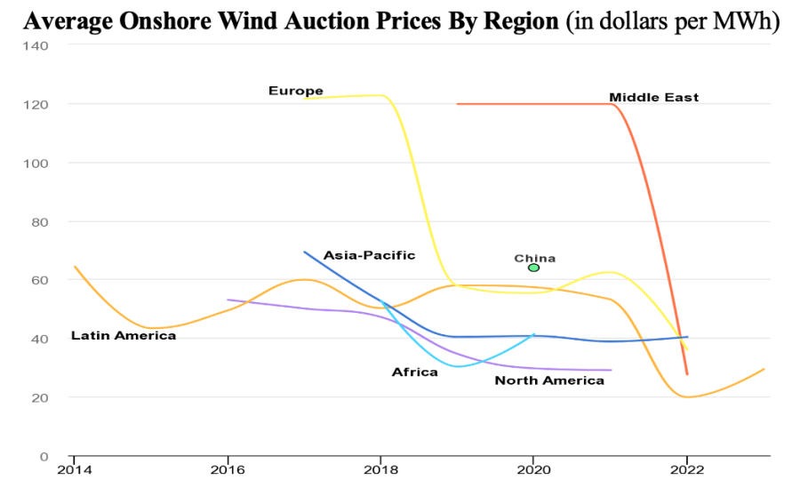
Source: IEA

Wind and solar energy dominated renewable capacity expansion worldwide in 2022, accounting ‎for 90% of all net renewable additions, leading to the highest growth in renewable generation ‎capacity on record, the Abu Dhabi-based International Renewable Energy Agency noted in a ‎March report. The Middle East also registered its largest expansion of renewable energy on ‎record, with 3.2 gigawatts of new capacity commissioned in 2022, the majority of which was ‎solar.‎

Despite this growth, in 2022 the Middle East had only 28.54 GW of installed renewable ‎generation capacity, or just 1% of total global capacity, the lowest of any region, though the ‎Middle East’s share will likely be slightly higher in 2023. The region’s onshore wind capacity in ‎‎2022 was around 1.05 GW, primarily concentrated in Iran and Jordan. Egypt, which IRENA ‎listed under the Africa region, had an estimated wind capacity of 1.64 GW in 2022 – more than ‎the entire Middle East – thanks to its installations located mainly in the Gulf of Suez, where wind ‎speeds can reach over 10 meters per second. In 2022, Morocco’s installed wind capacity was ‎estimated at 1.56 GW, slightly higher than its solar capacity.‎

Solar and Wind in the Middle East

If Middle Eastern countries hope to reduce emissions and reach their net-zero targets, solar and wind energy must be scaled up to provide zero-carbon energy and displace natural gas, which the Gulf Arab states are heavily reliant on for power generation.

Jordan, lacking significant oil or gas reserves, has few nonrenewable alternatives to ensure its energy security and has invested in both solar and wind projects. The same applies to Morocco, which was an early starter in developing renewables but still relies on oil and gas imports for 90% of its energy.

Egypt, where oil production has declined and gas is being prioritized to cash in on a surge in demand for liquefied natural gas, has attracted substantial investment in wind and solar ventures. Egypt has 1.56 GW of installed solar photovoltaic capacity and 1.59 GW of wind capacity. A 250-MW wind farm on the Gulf of Suez will come online later this year as part of Cairo’s plans to add 1.5 GW of wind capacity by 2025.

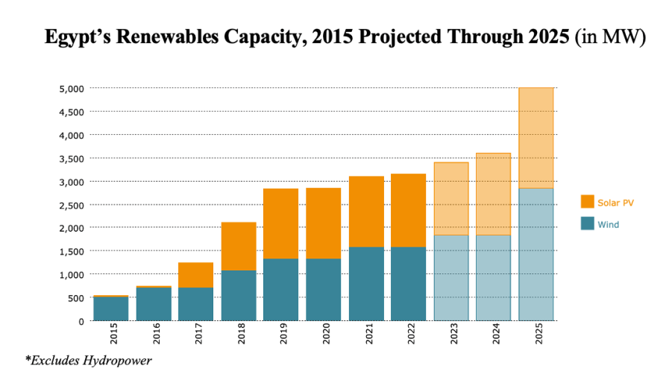Source: MEES

The United Nations Climate Change Conference, COP27, held in Egypt in late 2022, provided a boost to the region’s renewable energy drive. A raft of renewable energy projects were completed in the run-up to the summit, and more climate commitments are expected at COP28, which will be hosted by the United Arab Emirates in November.

The UAE has the most diversified energy mix of the Gulf oil exporters, with a combination of ‎natural gas, solar power, and nuclear energy. Other Gulf states have lagged behind in tapping ‎into their renewable resources, though Saudi Arabia has set ambitious clean energy targets, ‎including in wind power.‎

Abu Dhabi’s investment in renewables and nuclear power has paid off, allowing the emirate to ‎meet rising demand for electricity and cut gas consumption. In 2022, with the third unit of the ‎Barakah nuclear power plant in operation, Abu Dhabi’s gas consumption fell to an 11-year low. ‎Once Barakah reaches full capacity, which is expected by 2024, the plant will provide 25% of ‎the UAE’s electricity needs, according to the Emirates Nuclear Energy Corporation.‎

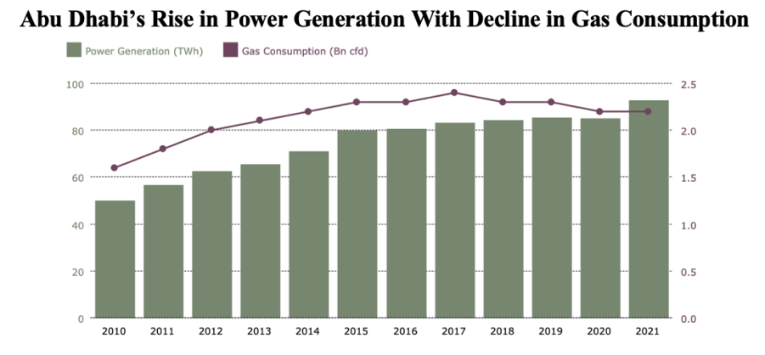Source: MEES

The contribution of renewables to the Saudi energy mix increased marginally in 2022 after the ‎‎400-MW Dumat al-Jandal wind farm went online in late 2021, but it remains small. However, ‎Riyadh has stepped up decarbonization efforts and plans to transition its power generation from ‎gas to renewables with the goal of reaching net-zero emissions by 2060. Although Saudi ‎Arabia’s renewables capacity makes up less than 0.4% of its total power generation capacity, ‎the kingdom is aiming for a 50-50 split between gas and renewables and is planning to increase ‎its renewables capacity by over 58 GW by the end of the decade. In addition, Saudi Arabia plans ‎to invest over $260 billion in its power sector by 2030 to boost clean energy generation capacity ‎and enhance its transmission and distribution networks.‎

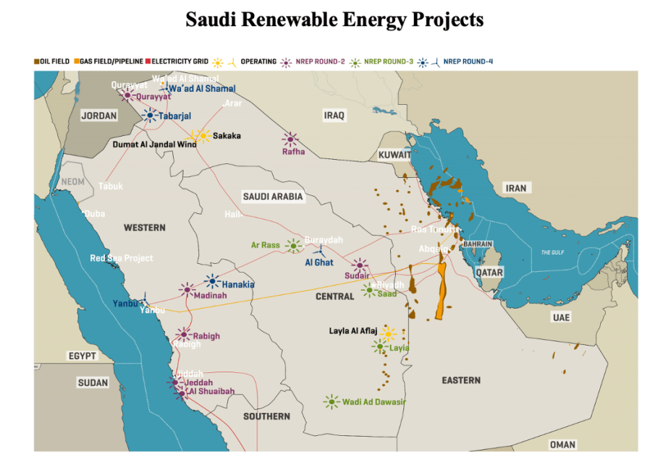
Source: MEES
Planned Saudi renewables projects include a 700-MW wind farm at Yanbu (Emirati clean energy ‎producer Masdar has a stake in the project). In total, Saudi Arabia has signed power purchase ‎agreements for renewables projects with a total output capacity of over 10 GW, according to ‎figures from MEES.‎

Masdar and Saudi Arabia’s ACWA Power have invested in several solar and wind projects ‎across the Middle East and North Africa, helping to drive the region’s energy transition forward. ‎ Saudi Arabia and the UAE are also betting on growth in demand for green hydrogen, which is ‎produced from renewable sources and could serve as a revenue source as the world transitions ‎away from fossil fuels.‎

Oman is also developing a green hydrogen industry and scaling up its renewable energy ‎capacity. Outside of solar projects, however, Oman’s only operational renewables project is the ‎modest 50-MW Dhofar wind project, which came online in 2019 after years of delay. The ‎sultanate plans to build two more wind farms by mid-2026 with a combined capacity of 300 MW, ‎bringing Oman’s total renewables capacity to 2.45 GW. As part of its Vision 2040 economic ‎reform program, Oman plans to build enough solar and wind installations to provide nearly 40% ‎of its electricity by 2040.‎

The IEA’s “Net Zero by 2050” scenario published in May 2021 calls for two-thirds of the world’s ‎energy supply to come from wind, solar, bioenergy, geothermal and hydropower by mid-‎century, requiring solar photovoltaic capacity to increase twentyfold and wind power capacity to ‎increase elevenfold. The report projects that by 2050, almost 90% of electricity generation must ‎come from renewable energy sources, with wind and solar photovoltaic power accounting for ‎‎70% of total renewable electricity generation.‎

The Path Forward for Gulf Producers

Events over the past two years have slowed the growth of installed wind capacity. The ‎coronavirus pandemic took the wind out of the sails of the energy transition, slowing industrial ‎activity and disrupting supply chains for key components. The situation has been exacerbated ‎by the Russia-Ukraine war, inflation and higher interest rates, and bureaucratic hurdles to ‎acquiring permits for wind projects in Europe, where the race to transition away from fossil fuels ‎has gained traction.‎

The IEA’s May 2021 report suggested that net-zero scenarios don’t require any new oil and gas ‎projects, a projection that rankled Gulf oil producers. But the report also stated that as ‎‎“traditional supply activities decline, the expertise of the oil and natural gas industry” aligns with ‎climate technologies such as hydrogen energy, carbon capture, utilization and storage, and ‎offshore wind, all of which “are needed to tackle emissions in sectors where reductions are ‎likely to be most challenging.”‎

COP28 offers the UAE and other Gulf Arab states the opportunity to showcase their green ‎credentials and prove that their net zero pledges and commitments are more than just hot air.‎

Kate Dourian is a non-resident fellow at the Arab Gulf States Institute in Washington, a contributing editor at MEES, and a fellow at the Energy Institute. (AGSIW 09.06)

Back to Table of Contents

  - MENA: First Quarter 2023 MENA Industry Venture Investment Brief

Magnitt's Q1/23 MENA Industry Venture Investment Brief examines the impact of the ongoing global economic challenges on the performance of three of MENA’s top ranking industries.

The first quarter of this year has witnessed a significant upheaval in the global financial sector and high inflation rates have made it impossible for an economic soft-landing scenario to materialize. Although the Federal Reserve's actions of continuously amplifying interest rates, which were followed by some Central Banks in the region, may have caused inflation to retreat, underlying price pressures remain sticky.

The MENA VC ecosystem experienced a sluggish start in 2023, with funding declining by 13% YoY and deals plummeting by 55%. The macroeconomic environment continued to drive up the cost of capital, leading to a more conservative investment approach, which further cooled down the market. This trend was reflected in MENA's top industries, including FinTech, Transport & Logistics and E-Commerce/Retail, which witnessed yearly declines in transactions and funding, except for the impact of the MEGA deals closed for FinTech and E-Commerce/Retail. Unfortunately, the Transport & Logistics industry suffered the most during the first quarter of this year. Given the challenging market environment, investors remain vigilant and cautious while making investment decisions and this is reflected clearly in both deal flow and funding evolution.

FinTech in the MENA region grew remarkably over the past years. The five-year CAGR of capital deployed in 2022 reported 77% highlighting the rapid expansion of the industry in the region. The focus on enhancing and automating several financial services, including Payment Solutions, Neobanking, Lending and Capital Market Services, has contributed to the industry's success. It is true that FinTech in MENA performed similar to the region overall, as capital deployed in the industry edged down by 9% YoY in Q1 and deals retreated to less than half their Q1/22 levels. The decline in funding for rounds less than $100M by an annual 64% is a significant concern, especially considering that these rounds make up the majority of FinTech deals in the region. Overall, while the Q1 results may not be as promising as previous quarters, it is essential to consider the broader economic context in the region and the impact of the ongoing global economic disturbances. The FinTech industry has shown resilience in the face of challenging circumstances and continues to be a realm of interest for investors in the region.

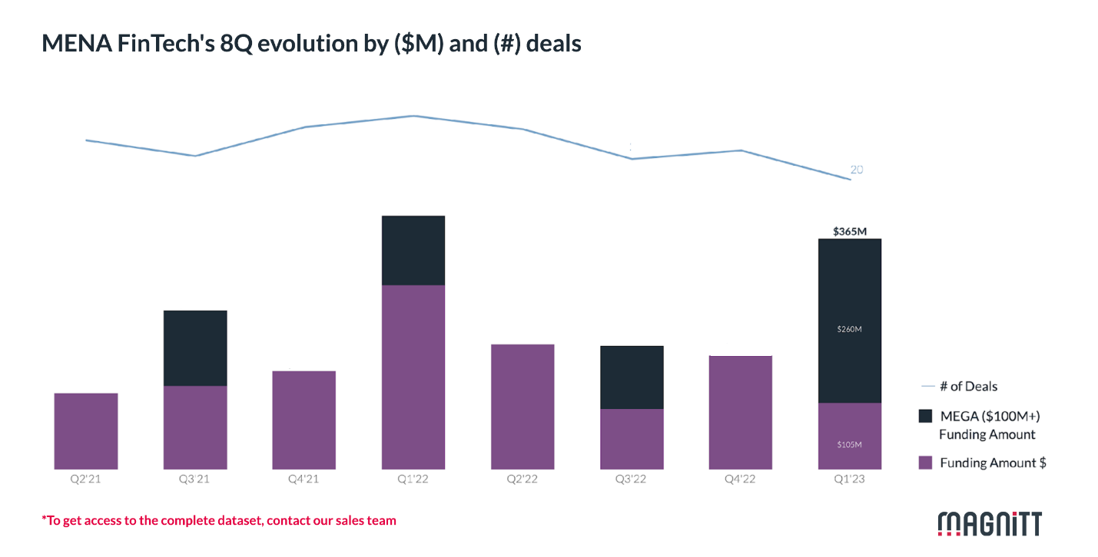

It is interesting to note the continued growth of E-commerce/Retail in the MENA region, driven by the increasing number of internet users and the rise of mobile access. The COVID-19 pandemic also played a significant role in accelerating the adoption of online shopping, as people looked for safer and more convenient ways to purchase goods and services. However, despite the impressive growth of the sector, challenges affecting the VC ecosystem have impacted investment and the growth of E-commerce/Retail in the region. The two MEGA deals that closed in Q1/23 for a total of $289 million are certainly of added value to the sector, but it is important to consider the broader context of the industry's funding landscape. Ignoring these MEGA deals, the non-MEGA deal funding level in Q1/23 was the lowest since Q3/20. This suggests that while there were still some significant deals, overall investment activity in the E-commerce/Retail sector in the MENA region has slowed down. The decrease in capital deployed in less than $100 million deals by 82% YoY in Q1/23 indicates that investors may be more cautious or selective in their investment decisions. The fact that the number of deals fell by 68% YoY to their lowest level since Q4/18 further underscores this trend.

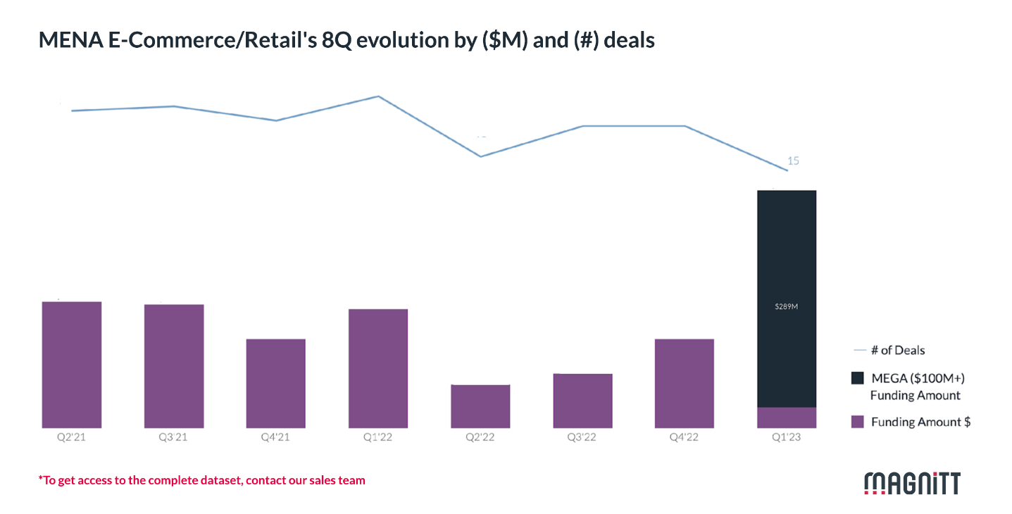

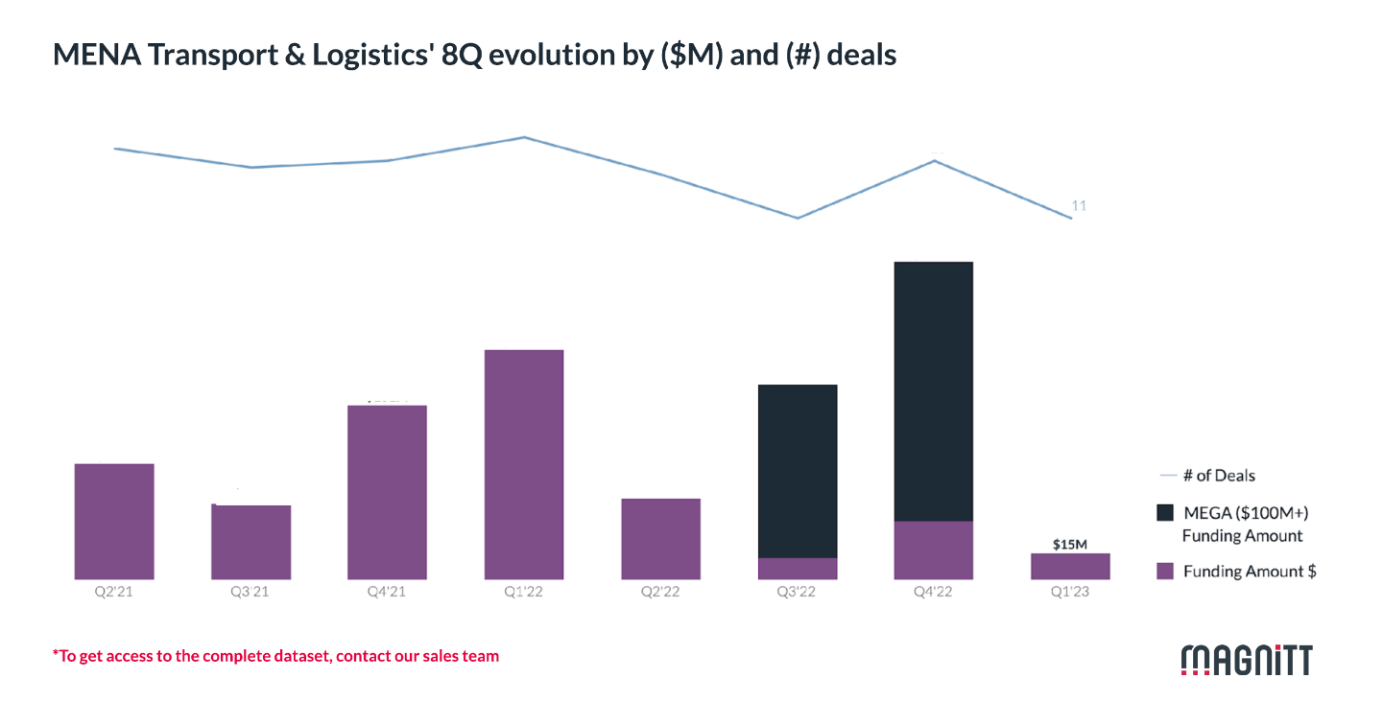

The fact that Q1/23 was the lowest funded quarter for T&L since Q3/19 (or Q3/22 if we remove the impact of the MEGA deal in that quarter) suggests that the ongoing financial vulnerability had a more significant impact on the industry compared to the pandemic era and its consequences. Overall, while Q1/23 was a challenging quarter for the Transport & Logistics sector in the MENA region. The fact that out of 11 deals closed for T&L in Q1/23, seven were of round size up to 1 million, indicates a risk-averse nature of investment in the industry. This trend may reflect a cautious approach by investors who are wary of the ongoing economic pressures and uncertainties. (Magnitt 08.06)

Back to Table of Contents

  - ISRAEL: IMF Executive Board Concludes 2023 Article IV Consultation with Israel

On 15 June, the Executive Board of the International Monetary Fund (IMF) concluded the Article IV consultation with Israel.

The IMF observed that Israel’s impressive economic performance continued in 2022. GDP increased 6.5% in 2022, led by domestic demand, with an increase in investment and consumption and with a minimal contribution from the government, as fiscal consolidation gained pace. Supported by strong economic growth and prudent fiscal policies, debt-to-GDP ratios fell to about 61% in 2022, down from about 71% during the Pandemic. Inflation remained high, at about 5% by end 2022, with the Central Bank of Israel following a tightening monetary policy to bring inflation rates on check. External demand was negative on net, as imports outgrew exports.

Economic activity is expected to decelerate in 2023, and thereafter converge towards its potential. Staff projects economic growth to slow to about 2.5% in 2023, as households' purchasing power moderates and firms rein in investment. The labor market is expected to remain tight and the unemployment rate is expected to marginally increase. Fiscal buffers are expected to be maintained as public debt to GDP is projected to decrease further and stay below 60%. The external sector is projected to remain robust. As domestic demand starts recovering from 2024, the growth rate is anticipated to converge towards its potential rate, estimated at about 3.8%; thus, closing the output gap in the medium term.

Executive Board Assessment

Executive Directors commended Israel’s remarkable economic performance and strong external position, noting that economic growth would slow down this year as it returns to potential over the medium term. Given downside risks to the outlook, Directors recommended that policies be geared toward protecting fiscal buffers, reducing inflation, maintaining macro-financial resilience and enhancing potential growth. They also cautioned that the uncertainty created by the proposed judicial reform could have a negative impact on the economy and called for a politically sustainable solution. Also, as in any country, maintaining the strength of the rule of law would be important for economic success.

They generally agreed that the fiscal stance is appropriate. Given the need to protect fiscal buffers, they considered that raising growth-enhancing spending in education and infrastructure will require additional revenue measures. Directors also encouraged the authorities to strengthen the fiscal framework, including by improving budgetary planning and considering the establishment of a fiscal council.

They commended the Bank of Israel’s tight monetary policy stance given elevated inflation and a tight labor market. They stressed that monetary policy should remain tight until there are clearer signs that aggregate demand is cooling and welcomed the central bank’s readiness to tighten policy further if needed. They emphasized that market forces should be allowed to continue to set the price of the shekel, with foreign exchange interventions limited to addressing disorderly market conditions.

They welcomed that the banking system remains broadly robust, while calling for close monitoring of risks, particularly those related to real estate lending. They also welcomed the tightening of macroprudential policies and encouraged efforts to raise the supply of housing. Further measures to improve the supervisory and AML/CFT frameworks would also be important.

They underscored the importance of enhancing potential growth and addressing inequality through reforms to close skill gaps, improve infrastructure and increase competition. They emphasized that education reforms and active labor market policies are particularly important for better integrating minorities in the economy. Directors also stressed the importance of reducing barriers to product market competition to address rising cost of living concerns. Regarding the climate agenda, they encouraged the authorities to press ahead with their commitments to reduce greenhouse gas emissions and adapt to climate change impacts. (IMF 15.06)

Back to Table of Contents
  - ISRAEL: Tightened Global Enforcement of US Export Controls Effect Israel

On 14 June, INSS Insight noted that the United States recently imposed a record fine for violation of US export controls. This case serves as a warning sign to Israeli companies, and can also inform the conduct needed from Israeli oversight authorities

The United States recently imposed a record fine on an overseas company that manufactures its products outside the borders of the United States, for violating US export controls. The incident demonstrates how the extraterritorial nature of the US rules of oversight over exports becomes a significant potential problem for Israeli companies, which could pay a hefty price for violating US export rules – even if they have not broken any Israeli laws. This case can also inform the conduct needed from Israeli oversight authorities to ensure that Israeli companies can continue doing business with China, while at the same time protecting these Israeli entities and avoiding stricter US oversight of the technological and economic activity on the Israel-US axis

Overseeing the export of US dual-use commodities, technology and software (i.e. civilian products that can also have defense applications) is the responsibility of the US Department of Commerce and is directed by the Bureau of Industry Security (BIS). BIS plays a key role in the trade war between the United States and China, especially in the battle of advanced technologies that are at the center of the microchip, semiconductor and supercomputer industries.

In April 2023, BIS imposed a civilian fine of $300 million on a company from Singapore and a US company, both of which belong to the Seagate Group. The fine was imposed as part of a settlement agreement, in light of accusations that between August 2020 and September 2021, the companies violated US export controls by selling 7.4 million hard drives that were manufactured outside the United States to the Chinese technology corporation Huawei – at a total cost of around $1.1 billion.

This is the largest civil fine ever imposed by BIS. The sum is more than double Seagate’s net profit from the prohibited deals, relegating the deals from highly profitable to outright losses. In addition, the compromise stipulates that Seagate will be subject to annual inspections regarding its conduct, and it was warned that if it violated export restrictions again in the next five years, its license to export goods under US oversight would be revoked.

Foreign Direct Product Rules

In August 2020, BIS began overseeing the export of certain goods manufactured outside of the United States to the Chinese Huawei group. The significance of this oversight was that any exporter wishing to sell these goods would need a BIS export license if Huawei were part of the deal and if the manufacture of the product (or any part of thereof) is based on US software or technology that is subject to export oversight by the United States.

These rules – which require an export license issued by the US administration, even for export from a third country, for products that were manufactured outside the United States, if they are the direct product of US technology that is under oversight – are known as the Foreign Direct Product (FDP) rules. To date, BIS has published 10 different FDP rules that prohibit the export of certain goods manufactured outside of the United States to certain countries, corporations, and end-users.

FDP rules have extraterritorial jurisdiction. They obligate companies that are not American to obtain a US export license for goods that have not been manufactured in the United States. The rules were set up to prevent sensitive US technology reaching problematic countries or users. The United States found that it was not enough just to oversee exports from the US or products that were manufactured in the US, since US interests were not represented by the export control laws of other countries. For example, Israel has a very different approach to China than the United States; Jerusalem has not imposed export restrictions on China similar to those imposed by Washington. Therefore, FDP rules are designed to ensure that products manufactured using technology that is under US oversight – even those manufactured outside of the United States – are subject to US oversight.

The Violation of FDP Rules

The production of the hard drives that Seagate sold to Huawei used US technology and equipment that is under oversight by virtue of the FDP rule issued in August 2020. Therefore, the sale of these hard drives to Huawei required the approval of BIS. The two other companies that supply hard drives to Huawei announced that they would be suspending their dealings with the Chinese company until BIS issued them an export license.

Nonetheless, Seagate continued to sell huge quantities of the hard drives to Huawei, becoming the company’s sole supplier of drives, at the expense of competitors that obeyed US law and stopped selling them. Subsequently, Seagate signed a strategic cooperation agreement with Huawei, making it the company’s strategic supplier and giving it preferential status among Huawei’s own suppliers. Seagate even provided Huawei with significant lines of credit, without which Huawei would not have been able to complete the purchases.

Israeli Companies Cannot Bury their Heads in the Sand

The Seagate case is an example of extraterritorial enforcement of American export oversight: enforcement against a Singaporean company for goods that were manufactured outside the United States, in the context of technology that is neither in the vanguard of cutting-edge technology nor of the Chinese threat to the United States. The fine imposed is huge not only because of the sums involved, but also because it made profitable illegal deals into losing propositions. Moreover, the company is now subject to stricter oversight and the threat of heftier sanctions if it violates export restrictions in the coming years.

The fine and the intensified oversight were imposed on Seagate for a violation that occurred before the significant tightening of export restrictions by the United States in the context of China, which were announced in October 2022, as part of the struggle between the superpowers over access to advanced technologies. Presumably any future violation of the new export restrictions would be met with an even harsher response.

The case of Seagate is not the only time that the United States has exercised extraterritorial jurisdiction over exports – also in cases outside the context of the FDP rules – against individuals or entities that acted against the interests of the US. For example, BIS also imposed sanctions against two Israeli companies – the NSO Group and Candiru – for allegedly working against United States foreign policy and security interests.

When it comes to the FDP rules, Israel is very much on the United States radar, since it is in the vanguard of technological advances – including regarding issues that are central to US oversight (such as semiconductors and advanced computing equipment). The Israeli hi-tech industry enjoys close connections with its US counterpart, thanks to research and development centers set up in Israel by US companies, US investment in Israel, and cooperation agreements between companies from both countries. At the same time, Israel also has commercial ties with countries and corporations that are targeted by United States export restrictions, including China. Since Israeli oversight of and restrictions on exports to these countries and corporations are far less strict than those of the United States, Israeli companies could find themselves in violation of FDP rules, even though they have not broken any Israeli laws.

Israeli companies that viewed the gaps in Chinese and other markets as an opportunity, following the decision by other companies to withdraw from those markets or to significantly scale back their operations due to restrictions imposed by the United States or the European Union, would be well advised to rethink that approach. The US administration has stressed that it views with the utmost severity the fact that Seagate expanded its dealings with Huawei in order to grab the market share of its competitors, who had obeyed FDP rules and curtailed all activity with Huawei.

A Lesson for Israel’s Oversight Authorities

Israel is entitled to determine its own export restrictions and not impose restrictions identical to those of the United States. At the same time, given the current regime of US export controls, and in light of bilateral strategic, economic, and technological relations, it is in Israel’s interests not to be considered problematic territory that enables de facto the flow of US technology in violation of US export restrictions, while clearly harming US interests.

The Israeli government must find the golden mean. It must enable trade with China while, at the same time stave off the danger of stricter enforcement vis-à-vis Israeli companies, limitations to the flow of technology, knowhow, and investments into Israel, and increased US pressure on Israel. When US House of Representatives Speaker Kevin McCarthy addressed the Knesset in May 2023, he made the connection between technological cooperation between Israel and the United States, and the need for Israel to tighten its oversight of investments by Chinese actors and Chinese access to Israeli technology and infrastructure. His cautionary tone was similar to messages relayed by previous US administrations – Republican and Democrat alike.

Israel is already exercising restraint when it comes to issuing export licenses for China; it does not issue licenses for defense exports and issues civilian licenses sparingly. Indeed, the Ministry of Economy and Industry demands that all exporters declare in writing while applying for a license that no foreign country has imposed export restrictions on its goods for re-export at a later stage. With the encouragement of the United States, Israel also established and tightened its mechanism for the oversight of foreign investments, implicitly focusing on Chinese investments.

Israel must inculcate in the local market the fact that Israeli export oversight is not the only oversight that it relevant, and that especially now, Israeli companies must ensure that they meet all the other relevant oversight rules, including those of the United States.

It is important that Israel maintain open lines of communication with the authorities in the United States, and that it inform Israeli companies of messages relayed by the US about potential concern over activity that violates US oversight rules. It is far better to create a dynamic in which anyone violating these rules is quietly given the opportunity to stop this behavior and rectify the situation – rather than having to intervene retroactively on behalf of Israeli companies once they are already subject to US enforcement measures.

Activity on the part of oversight authorities in Israel – in a manner that recognizes recent changes in US policy regarding exports of technology but does not bind Israel to it – will help prevent violations by Israeli companies, likely increase protection for companies violating these rules, and bolster US confidence that its technologies are safe in Israeli hands. This could help advance the easing of US export controls to Israel (as in the cases of Japan and Australia) and ease access to US security grants or security procurement from Israeli suppliers.

Adv. Ofer Granot is a visiting senior fellow in the Diane and Guilford Glazer Israel-China Policy Center at the Institute for National Security Studies (INSS) and a partner in the law firm of Herzog, Fox & Neeman. Adv. Daniel Rosenblatt is an expert on international trade at Herzog, Fox & Neeman. (INSS 14.06)

Back to Table of Contents

  - ISRAEL: Trends in Trade with China Over the Past Decade (2013–2022)

In an INSS Special Publication of 18 June, Tomer Fadlon has produced a broad overview of the trends in Israel's trade with China in goods and services, in the last decade

Introduction

This paper surveys the trends in trade between Israel and China, in both goods and services, over the past decade (2013–2022). Especially noticeable is the significant and consistent rise in trade with Israel during those years, based mostly on the import of goods from China, which totaled $17.62 billion in 2022. The imports from China are diverse and include machinery for infrastructure and construction projects, consumer products ordered from Chinese websites, which to some degree has mitigated the rise in the cost of living in Israel, and for the past two years, the import of cars from China. This paper also analyzes the balance of trade between Israel and China compared to the two other economic blocs with which Israel has extensive trade relations – the United States and the European Union. Despite the increase in traded goods with China, the volume of trade remains relatively smaller in comparison to that of the European Union ($49.19 billion) and the United States ($22.04 billion). Similarly, while Israel’s trade in business services with the European Union and the United States is a key component in their trade relations, it is almost non-existent with China.

Israel – China Trade Relations

Trade relations between Israel and China have been consistently and continuously trending upward, especially when it comes to goods. Between 2018 and 2020, the volume of trade with China (not including trade with Hong Kong or in diamonds) was stable, while in 2021–2022 the trade in goods – and, in fact, the import thereof – climbed significantly. According to the Israel Central Bureau of Statistics (CBS), the volume of trade in goods in 2021 increased by 27% compared to 2020, and in 2022, it further rose by 17% compared to 2021. In total, the volume of goods traded increased by almost 50% in 2022 compared to 2020 – $17.62 billion compared to $11.83 billion. Of this, imports from China rose from $6.75 billion to $13.12 billion. This is a significant increase of around 71%, while imports grew from $4.18 billion to $4.5 billion – an increase of just 7.5%. Figure 1 below shows that Israel exported goods valued at $4.5 billion to China in 2022, while it imported goods worth $13.12 billion. Similarly, China is one of the only countries in the world with which Israel’s volume of trade increased in 2020, when the COVID-19 pandemic began. In 2020, trade with China increased by 5% compared to 2019. It should be noted that Israel deviates only slightly from the global trend during those years, since Chinese exports to the world rose by 38% in 2022 compared to 2020.

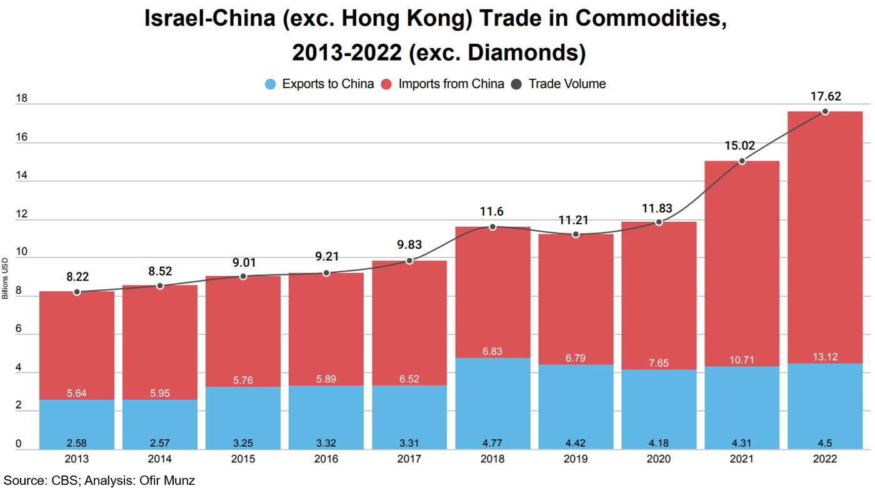

The dramatic increase in the volume of trade in the past two years was due mainly to imports of goods from China. From 2019 to 2022, annual trade with China increased by $6.41 billion (an increase of 57%), from $11.21 billion in trade in 2019 to $17.62 billion in 2022. Of that, $6.33 billion reflects an increase in imports from China, having increased from $6.79 billion in 2019 to $13.12 billion in 2022, while only $0.08 billion of this is from an increase in exports to China, which climbed from $4.42 billion in 2019 to $4.5 billion in 2022. In other words, analyzing the dramatic increase in trade between the two countries shows that imports from China are responsible for 98.8% of the increase, while the contribution of exports to China to this increase is marginal, standing at just 1.2%. It should be noted that the minimal increase in exports does not characterize the overall trend in Israeli exports. According to Israel’s Ministry of Economy and Industry, in 2022 alone there was a 15.5% increase in exporting Israeli goods abroad compared to 2021. The notable surge in imports from China can be attributed to various factors, including:

- An increase in online purchases from China, primarily from two websites: “Ali Express,” which for several years has been one of the most-visited websites among Israelis and during the period surveyed was the most popular website for Israelis to purchase merchandise from overseas and, in certain months, was even more popular than Israeli online shopping sites; and the online fashion store “Shein,” where Israelis spent the most money ($250 million) among the foreign-based shopping sites in 2022, and second only to the Israeli supermarket chain “Shufersal” among all the online shopping services. Notwithstanding its relatively small population, Israel is among the leading countries in the world in terms of visiting and purchasing from these two Chinese websites, which are seen as an effective method of countering the rising cost of living. For most purchases, Israelis take advantage of the exemption from Value Added Tax by ensuring that each purchase comes to less than $75.

- The entry of many brands of Chinese-made vehicles to the Israel market between 2021 and 2023, as detailed below.

- An increase in the purchase of electronic products and other goods for remote work. Despite the increase in online purchases, the majority of imports from China do not follow a direct path from the Chinese seller to the Israeli consumer but rather through stores operated by official importers. The goods available at “Max Stock,” a chain of Israeli department stores, for example, are first purchased by the Israeli importer and then sold in stores across Israel.

Meanwhile, Israeli exports to China reached an all-time high in 2018, with exports of goods totaling $4.77 billion. During that year, exports increased by 44% compared to the previous year, when the total was $3.31 billion, thanks to a growth in the exporting of electronic components, including microchips manufactured by Intel in Israel. In fact, the $1.2 billion increase in the export of electronic components in 2018 compared to 2017 – $2.6 billion of electronic component exports in 2018 compared to $1.4 billion in 2017 – constituted most of the $1.46 billion increase that year in Israel’s total exports to China. CBS figures for 2021 show that Israeli exports to China fell into two main categories: computers, electronic and optic equipment; and minerals and mining materials, chemicals, and metals (see Figure 2). According to the Israeli Ministry of Economy and Industry, the export of medical and optical equipment to China increased by 37% in 2021, as a result of both the COVID-19 pandemic, which began the previous year, and China’s 14th five-year plan, which was published early in 2021 and highlighted the importance of health and innovation – partly to address the country’s aging population. In other words, the export of goods produced by Israeli companies in various medical fields increased because of China’s need to treat chronic diseases and to help its elderly population. In addition, the export of chemicals, including fertilizers, grew by 30%. Yet despite this increase, Israeli exports of goods to China are still relatively limited and suffer from a lack of diversity, relying heavily on the exports of electronic components, especially microchips manufactured by Intel.

Although Israel’s export of goods to China decreased in 2022, valued at $4.5 billion compared to the record level of $4.77 billion in 2018, China still plays a relatively important role in Israel’s exporting of goods. In 2020, exports to China exceeded the value of exports to the United Kingdom ($3.6 billion), thereby becoming the second most important export destination for Israeli goods after the United States (excluding the European Union bloc of countries). However, when one takes the economic blocs into account, the export totaling of $4.18 billion puts China in third place, behind the exports to the European Union and the United States in 2020, which stood at $14.6 billion and $10.4 billion, respectively. Similarly, it should be remembered that Israeli companies could face difficulties exporting microchips and other advanced technological equipment because of the tension between the superpowers and American restrictions in sensitive areas. The export of electronic components makes up more than half of all of Israel’s exports to China and the concern is that Israel’s relative advantage in exporting technology could limit exports to China and lead to the non-realization of the export potential.

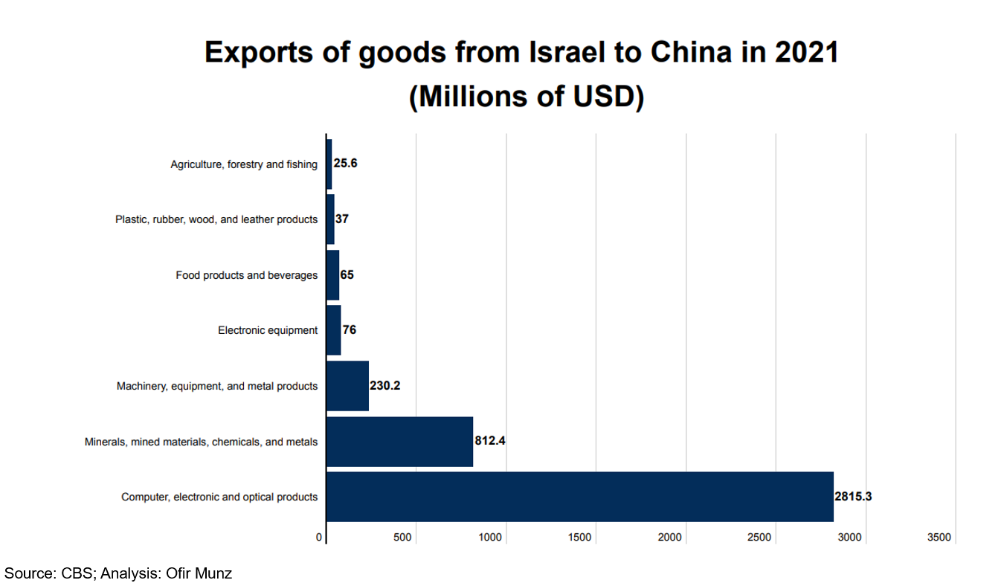

The dramatic rise in the import of goods from China, alongside the stagnation in the export of goods, has increased Israel’s trade deficit year after year, setting a new record in 2022. Last year, the trade deficit stood at $8.62 billion, compared to $6.4 billion in 2021. In fact, Israel’s trade deficit with China has increased by around 360% since 2019, from $2.37 billion in 2019 to $8.62 billion in 2022 – a faster rate of increase than with any other country (see Figure 3). The CBS review shows that Israel’s trade deficit with China is the highest of all the countries that it trades with – far ahead of second-placed Switzerland with which Israel had a trade deficit of $5.5 billion in 2022. On the other side, Israel’s greatest trade surplus in 2022 was with the United States ($4.6 billion).

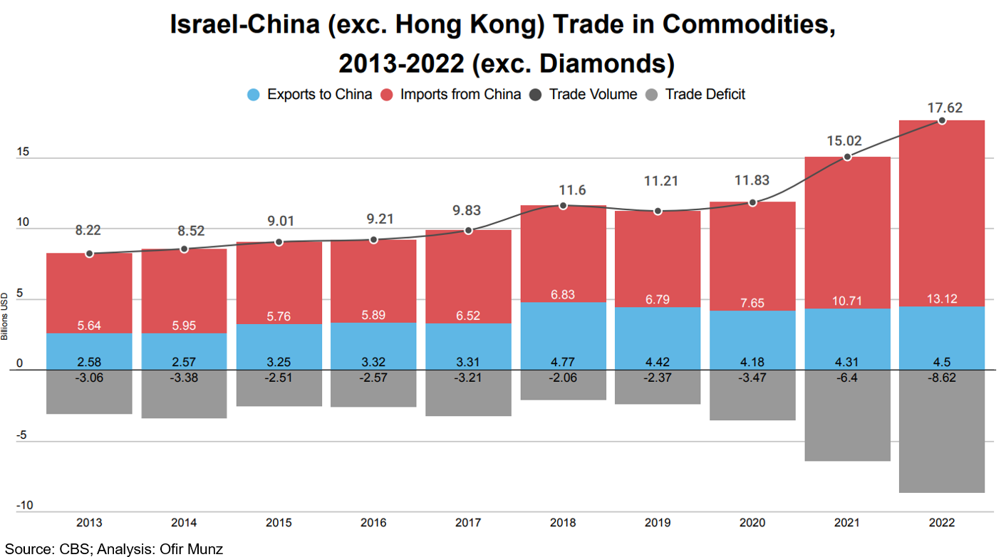

The significant increase in imports of goods from China in recent years, at a time when exports plateaued, has led to an ongoing increase in Israel’s trade deficit with China. Indeed, each of the past three years has seen the deficit reach record levels. In 2020, the deficit stood at $3.47 billion, compared to the previous record of $3.21 billion, which was set in 2017. In 2021, the deficit rose significantly to $6.4 billion and in 2022, as mentioned, it crossed the $8 billion threshold. Israel is far from unique when it comes to having a trade deficit with China, since this is the case for most countries. When China became the “world’s factory,” it also turned into a country that enjoys a consistent trade surplus. As of 2021, China was the country with the highest trade surplus in the world – $675 billion – considerably ahead of Germany in second place, which has a trade surplus of $211 billion.

Trade in Goods: A Comparative Analysis

Over the past decade (2013–2022), Israel’s trade in goods has steadily increased (see Figure 4). In 2013, for example, Israel’s global trade in goods stood at $120 billion; by 2022 this trade had risen to around $162 billion – an increase of 35%. Over the same period, the volume of trade in goods between Israel and China increased by around 115%, from $8.22 billion in 2013 to $17.62 billion in 2022. China alone accounts for approximately one-quarter of the growth in goods trade between Israel and the rest of the world.

Trade with the United States increased during the same period by 26%, from $17.43 billion to $22.04 billion, while trade with the European Union rose by 34%, from $36.7 billion to $49.19 billion. It is important to note that, during those years, the calculation method for trade with the European Union underwent changes by the CBS, and since 2021, trade with the United Kingdom has been calculated separately because of Brexit. Similarly, the proportion of trade with China increased during those years from 6.8% ($8.22 billion) of Israel’s total global volume of trade in goods in 2013 to 11% ($17.62 billion) in 2022. Even after this increase, China is still the third largest trade partner, following the European Union at 31% of Israel’s total global trade in goods, and the US at 13.5%.

It should be noted that the volume of trade with China is greater than any individual trading partner from the European Union. When analyzing the imports of goods, the European Union takes the lead followed by China in second place. However, upon closer examination of individual countries, the import of goods from China surpasses any other country significantly, amounting to $13.1 billion in 2022. In comparison, imports from the United States accounted for $8.7 billion, and imports from Germany amounted to $7.1 billion.

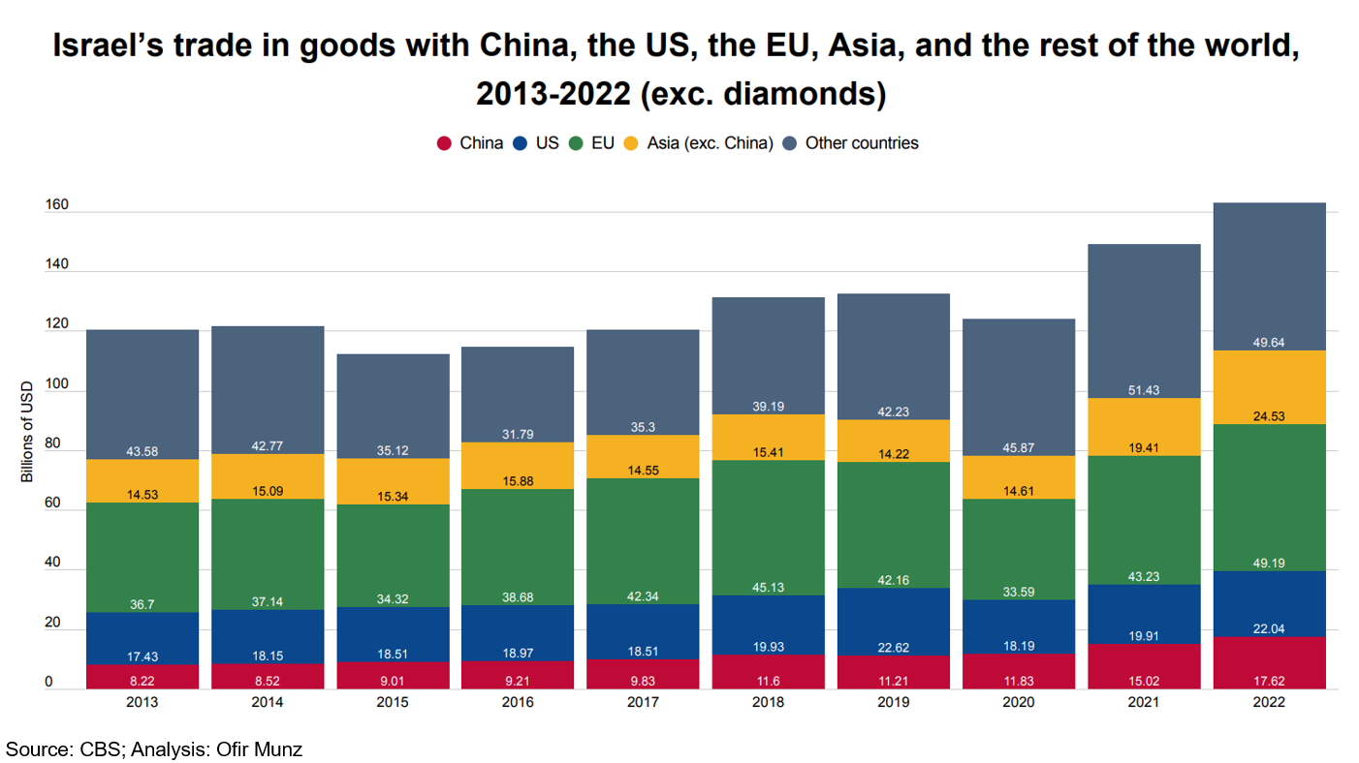

Several conclusions can be drawn from a broad analysis of Israel’s trade in goods with China compared to the other large economic blocs in recent years. First of all, trade with China has grown consistently and even rose in 2020 compared to the previous year. Due to the influence of the COVID-19 pandemic, trade with the other two blocs dropped significantly in 2020. Secondly, trade with the United States has still not returned to its pre-pandemic levels, while trade with China has grown by almost 50% since then. Thirdly, despite the concerns that an economic slowdown would harm trade with the European Union and of a possible boycott of Israeli goods, trade has increased with the European Union. While the COVID-19 pandemic exacerbated these concerns, trade increased by 16% in 2022 compared to 2019. Fourthly, trade with Asia continues to trend upward even without China, having increased by 72% compared to 2019. This is a good representation of Israel’s eastward expansion and the variety of trade relations it enjoys.

The figures presented here are based on the way the CBS and the World Trade Organization categorize China in the global trade system. That is, China and Hong Kong are seen as two separate entities when it comes to global trade. From a geopolitical perspective, there is some logic in analyzing trade with Hong Kong as part of the trade with China, given that China controls Hong Kong and can influence Hong Kong’s economy for political considerations and can use the territory to advance its own strategic interests. However, even if we were to examine the data of the two economic entities as one unit, it would not significantly change the overall picture. In this case, trade with China, including Hong Kong, would still be the third largest, after the European Union and the United States, with a combined volume of trade in goods of $21.08 billion in 2022 (see Figure 5). The only aspect that would vary is the proportion and significance of trade with China, including Hong Kong, since the proportion would rise from around 11% to 13% of Israel’s total global trade. Similarly, according to the trend of increased imports from China in recent years, it is feasible that trade in goods with China, including Hong Kong, could surpass trade in goods with the United States by 2023.

Car Imports from China

The arrival of Chinese vehicles on Israeli roads is one of the most interesting phenomena in terms of Sino–Israeli trade relations. Up until 2022, the most common Chinese car on the Israeli roads was the British MG brand, which the Chinese company SAIC Motor purchased in 2005 and manufactures in China. Geely overtook the sales of Tesla and ended 2022 as the best-selling brand of electric vehicle in Israel. With close to 7,000 deliveries in 2022, Geely sales increased by 4,000% compared to 2021 (see Figure 6). In fact, the list of the 10 best-selling electric vehicles in Israel contains six Chinese manufacturers. Therefore, it is not surprising that more than half of the electric vehicles sold in Israel in 2022 (14,300 out of 27,600 vehicles) were Chinese brands. Sales of some brands could have been even higher were it not for supply-chain issues, which slightly reduced the number of vehicles imported.

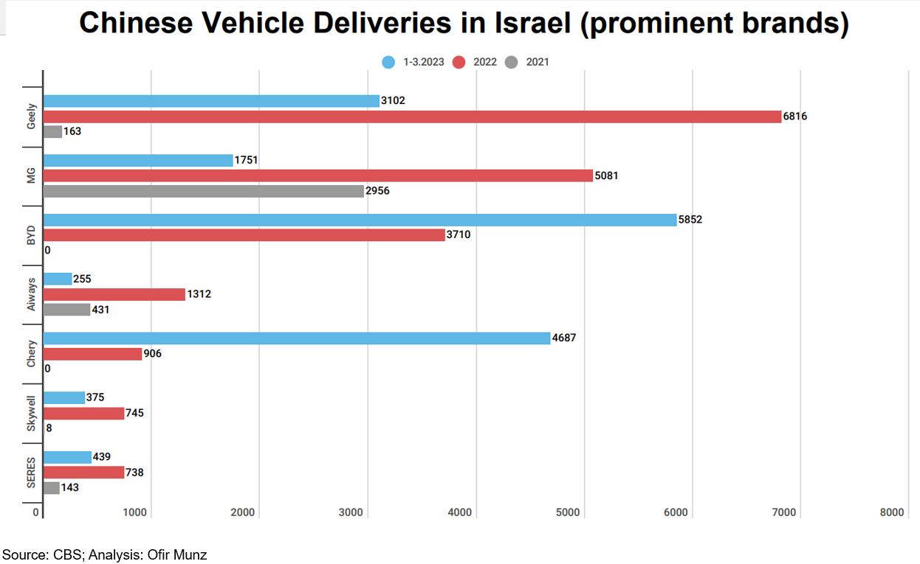

It is evident that this trend continued through the first quarter of 2023, when the import of cars from China set new records. Between January and March, around 105,000 vehicles were delivered in Israel – and more than 12,000 of them were Chinese brands. The new brand – Chery – delivered 4,687 vehicles. At the current rate, the number of Chinese vehicles delivered by the end of 2023 is expected to double from the previous year. According to Chinese tariff figures, in January and February of 2023, Israel became the third largest destination for Chinese car exports, after Russia and Mexico. It is possible that the dramatic increase stems, inter alia, from the wish of the consumers to avoid the rise in purchase tax on electric cars: in January 2023, purchase tax rose from 10% to 20%, and it is likely to reach 35% in January 2024.

The increase in the exports of Chinese vehicles is not a phenomenon that is unique to Israel. In 2022, China exported more than 2.5 million passenger vehicles, an increase of 56% compared to the previous year. Chinese vehicles have gained in popularity across the world mainly because of price considerations. Electric vehicles are more expensive than diesel or gasoline-powered vehicles and Chinese electric vehicles are not only cheaper than competing electric vehicles, but also cost less than some non-electric vehicles. In fact, Chinese vehicle exports have surpassed most major car-manufacturing giants – including Germany – making China the second largest exporter of cars after Japan. However, the export and delivery of vehicles around the world only tells part of the story, since international trade is usually measured according to value, not quantity. As a result, in 2021, the last year for which we have data about the value of vehicle exports, China was in fourth place globally in terms of quantity, but in 12th place in terms of the value of those exports. China is taking over the global car market – even if not in terms of value.

Trade in Business Services

Despite the impressive growth in Israel’s volume of trade with China, most of the increase is from trade in goods, while trade in business services, which represents the main catalyst in Israel’s international trade, remains far behind. According to data from the World Trade Organization for 2021, 40% of Israel’s international trade is in business services. Moreover, the export of business services is the most important element of Israel’s international trade and has been on a constant upward trend in recent years, thanks to high demand for Israeli computer and information technology services, as well as Israeli research and development, which gained an international reputation even before the COVID-19 pandemic. The pandemic gave these industries a significant boost, expanding demand for computer services from Israeli companies. In 2021, Israel exported business services with a value of $60.7 billion, a significant increase of 50% compared to 2018 ($40.4 billion). The import of business services also grew significantly during that period, but not to the same extent: from $15.5 billion in 2019 to $20.3 billion in 2021 (30% growth).

Trade in business services is most developed with the United States and the EU, which accounts for more than half of Israel’s trade in business services. According to CBS figures, around one third of the total of Israel’s trade in business services for 2021 was with the United States (trade valued at $25.98 billion out of a total of $81 billion), while 10.7% ($8.74 billion) was with the European Union (see Figure 7). Trade in business services between Israel and China is almost nonexistent.

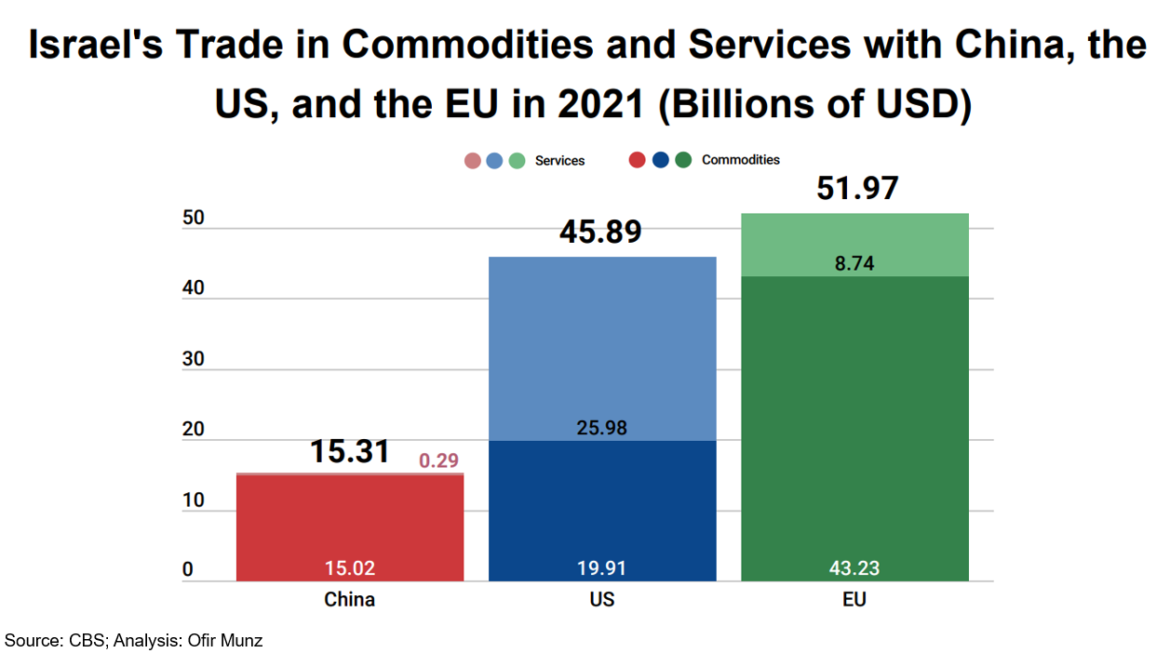

In 2021, Israel exported $154 million worth of business services to China and imported business services valued at $143 million (see Figure 8). Hence, the export of business services to China constituted 0.25% of Israel’s total exports of business services in 2021, while imports of business services from China amounted to 0.75% of all business services imports. Apart from these low figures, in 2021 the upward trend in trade in business services between the two countries came to an end, and both the import and export of business services have decreased. The export of business services dropped by around 10%, while the import of business services dropped even more sharply. After setting a new import record for business services in 2022 – $255 million – Israel’s import shrank by more than 50% to $143 million in 2021.

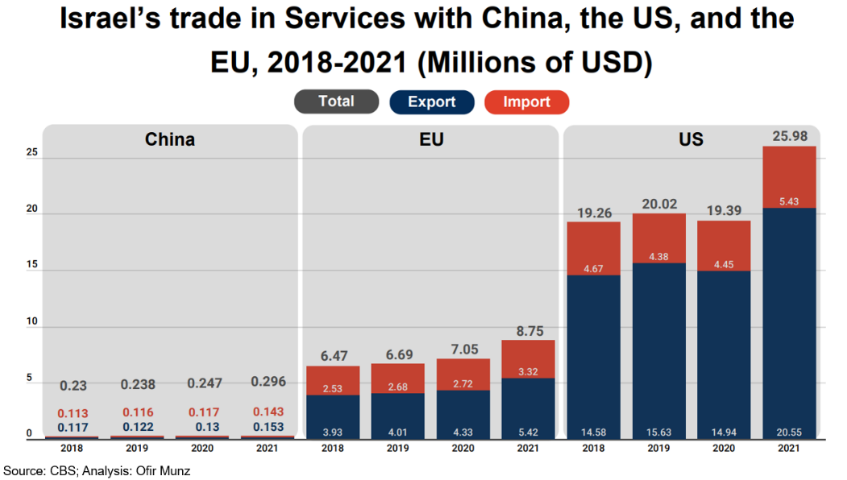

By analyzing the segmentation of the export of business services to China in 2021, it is apparent that around one-third of the total exports are computer and information technology services ($49.5 million) (see Figure 9). This figure is in line with the general trend since these services also make up around 40% of the total export of business services from Israel. However, when it comes to the types of services, it is evident that China does not follow the prevalent trend. Intellectual property royalties make up more than one quarter of Israel’s exports to China ($39.67 million), while they make up just 1.3% ($748 million) of the total value of business services exports from Israel in 2021. The gaps are also evident when it comes to construction services, which make up more than one fifth of Israel’s business services exports to China ($32.18 million), while they make up only a tiny fraction ($638 million) of Israel’s total exports of business services. Similarly, research and development, which makes up more than 15% ($9.4 billion) of the total Israeli export of business services, constitutes around 2% of business service exports to China. The gaps in this kind of service are prominent when comparing China to the United States: $7.8 billion of R&D exports to the United States, compared to just $3 million to China.

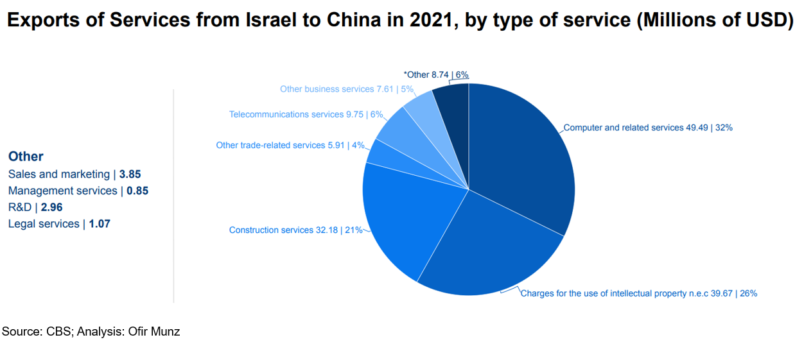
Analyzing the segmentation of business services imports reveal an interesting picture, which explains the significant differences between 2020 and 2021. In 2020, around half of Israeli imports of business services from China ($129.5 million) focused on renting equipment for several large-scale infrastructure projects in Israel, including the Tel Aviv light rail transit project. This clause remains blank in the CBS figures for 2021 and explains the sharp drop in the import of business services from China in 2021. Construction services, which account for around 3% of Israel’s total import of services in 2021, make up more than a quarter of the import of services from China for the same year ($37.57 million) (see Figure 10). Other industries, which are well developed when it comes to trade with OECD members and make up a substantial proportion of Israel’s imports of business services, are not developed at all with China. These services include financial, business, advertising, computing, and sales and marketing services.

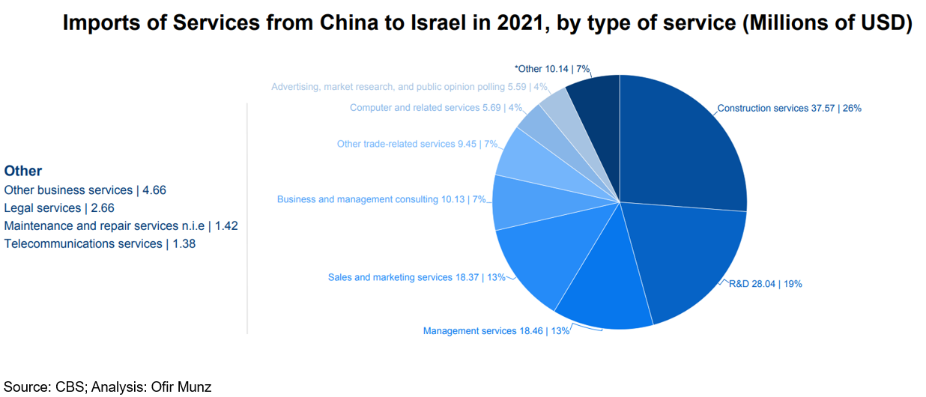

Conclusion

Analyzing the volume of trade between Israel and China paints a clear picture of a constant upward trend. During the COVID-19 pandemic, China stood out as one of the very few trade partners in the world with which trade with Israel experienced growth. However, a deeper look at the trade balance between the two countries shows a more complicated picture. Trade relations between the two countries rely heavily on the import of goods from China to Israel, which makes up around 70% of the total international trade in goods and services between the two countries. This trend continues in light of the volume of Israeli goods exported to China, which is based primarily on the activities of two main companies and has not risen significantly since 2018. These trends significantly increase the trade deficit between the two countries, which peaked in 2021 – the same year in which the import of Chinese vehicles to Israel became a significant factor. Israel must avoid a situation of being overly dependent on the import of goods from China and must continue to import from a variety of countries – especially when tensions between the superpowers have increased. Similarly, trade in business services between the two countries is almost nonexistent. Indeed, China is a superpower in terms of international trade in goods, but not in services, which make up just 10% of its total international trade. In Israel’s case, however, trade in business services has shrunk to less than 1% annually and is not a significant factor in bilateral trade. In fact, there is a significant gap between Israel’s export potential, which in recent years has become a major exporter of these services, and the realization of the negligible potential in terms of trade in business services with China.

These two phenomena are entirely different from Israel’s trade with the United States and the European Union. With these two countries, there is significant trade in business services, which largely explains the growth in the volume of trade. For example, while trade in goods with the United States has not yet reached its pre-COVID-19 level, trade in business services significantly trends upward every year. Therefore, despite the growing importance of China as Israel’s trading partner, the volume of trade with the United States and the European Union and the diversity in the ratio between imports and exports and between goods and services explain why China is still the third most important trading partner for Israel, with trade in goods totaling $17.62 billion in 2022, and constituting about 11% of Israel’s total trade in goods in 2022. This, of course, is contrary to the global trend, according to which China is the largest trading partner of more than a hundred countries in the world.

Similarly, increasing imports from China raises questions about the future of the free-trade agreement between Israel and China, an issue that has been on the agenda since 2016. The consistent growth in imports from China adds funds to the treasury, thanks to the various tariffs, including on batteries and vehicles. A free-trade agreement would significantly reduce the state revenues from these tariffs, and, during periods of economic uncertainty, it is hard to envisage that the Israeli Finance Ministry would rush to give up the large revenues resulting from the increasing imports from China.

Beyond this, the discussion of trade with China would be incomplete without acknowledging the great power competition and its possible ramifications on international trade. The increased tensions between Washington and Beijing since the start of the trade war have affected Israeli exports to China. The concern of Israeli companies that their activities vis-à-vis the United States could be threatened could make Israeli exports to China even more difficult and could lead to a drop in overall exports to China as the conflict between the superpowers intensifies. Therefore, Israel is forced to conduct its trade relations with China out of economic and commercial interests, while taking into consideration US demands and taking advantage of opportunities along the way. Israel’s relative advantage in technological fields, especially the export of hi-tech services, is currently limited in terms of development potential vis-à-vis China and may become even more restricted in the future. In contrast, some of the life science and medical fields, currently of interest to the Chinese, have the potential to expand their exports from Israel, without creating any superfluous tensions with Washington. China’s emphasis on health and its aging population creates a golden opportunity for the export of Israeli pharmaceutical companies and medical equipment to China, without getting involved in the great power competition. In recent years, China’s population over the age of 60 has climbed steadily, from around 13% in 2010 to 18% today and is projected to reach 26.2% by 2030. Israel, therefore, should focus, inter alia, on exporting goods and services in those fields, to increase the volume of trade with the world’s second largest economic power. (INSS 18.06)

Back to Table of Contents

  - OMAN: IMF Staff Concludes Staff Visit to Oman

A staff team from the International Monetary Fund (IMF) visited Muscat, Oman, during 6-14 June to discuss economic and financial developments, the outlook, and the country’s policy and reform priorities. At the conclusion of the mission, the IMF issued the following statement:

“Oman’s economy continues to grow, and inflation is contained at low levels. Real GDP grew by 4.3% in 2022, primarily driven by a strong expansion of the hydrocarbon sector. Economic growth is, however, projected to slow down to 1.3% in 2023 and then rebound to 2.7% in 2024, reflecting oil production cuts by OPEC+ and moderate growth in the non-hydrocarbon sector due to recovering but still subdued construction activity, a slowdown in global economic activity, and tighter financial conditions. Nevertheless, non-hydrocarbon growth is projected to rise to 2% in 2023 and 2.5% in 2024, from 1.2% in 2022. Headline inflation eased from 2.8% (year-over-year) in 2022 to 1.1% by April 2023 (year-over-year), reflecting lower food inflation and a stronger US dollar.

“Substantial oil windfalls and fiscal consolidation have boosted fiscal and external positions. The fiscal balance reached a surplus of 7.5% of GDP in 2022 and is expected to remain in surplus over the medium term on the back of favorable oil revenues and fiscal measures under the authorities’ Medium-Term Fiscal Plan. Alongside, central government debt as a share of GDP declined significantly from 61.3% in 2021 to 40% in 2022, as the authorities used the oil windfall to repay government debt. State-owned enterprises (SOEs) debt as a share of GDP declined from 40.7% in 2021 to 28.8% in 2022, on the back of asset divestments, improved performance, and debt repayments, with risks mitigated by substantial assets under Oman Investment Authority’s management and ongoing reforms in the sector. Buoyed by oil and non-oil exports, the current account in 2022 recorded its first surplus since 2014, at 5.2% of GDP, and is projected to remain in surplus over the medium term. Gross international reserves held by the Central Bank of Oman stood at $17.6 billion in 2022 (4.7 months of prospective imports).

“The banking sector remains sound. Profitability has recovered from pandemic lows. Banks display ample capital and liquidity buffers. Asset quality remains strong while credit to the private sector continues to expand.

“The near- to medium-term outlook is favorable and risks to the outlook are balanced. On the upside, growth and fiscal and external positions would be spurred by accelerated production at the Duqm refinery project and by another surge of oil prices—that could be triggered by supply and demand imbalances—, an acceleration of Vision 2040 reform plans, and a rise in foreign direct investments from regional partners. On the downside, a sharp decline in oil prices—due to a severe and protracted global economic slowdown—, lower demand for hydrocarbons—due to a faster-than-expected global energy transition—, and pressures to spend the oil windfall represent key risks to the outlook.

“Going forward, the authorities’ structural agenda under Oman’s Vision 2040 will support stronger, private sector-led, job-rich non-hydrocarbon growth while entrenching fiscal and external sustainability. Priority areas include allowing for greater labor market flexibility, enhancing social protection and insurance, improving tax collection efficiency, strengthening medium-term fiscal frameworks, enhancing the performance and transparency of the SOE sector, creating an investor-friendly business environment, accelerating the pace of digitalization, developing the financial sector, and investing in green energy to help address climate challenges and leverage the global energy transition. (IMF 19.06)

Back to Table of Contents

  - SAUDI ARABIA: Staff Concluding Statement of the 2023 Article IV Mission

On 7 June the IMF issued a concluding statement at the end of an Article IV mission to Saudi Arabia.

The Saudi economy is booming, spurred by high oil prices, a strong pick up in private investment and reform implementation. The current account surplus has reached a decade-high surplus and inflation is contained. Uncertainty in the global economy—both impacting financial conditions and oil prices—requires continued efforts to further build buffers and diversify the economy. Going forward, continued fiscal reforms, coupled with careful calibration of investment programs, will help strengthen fiscal and external sustainability while implementation of the impressive structural reform agenda will help generate a strong, inclusive and more sustainable growth.

Recent Economic Developments

Saudi Arabia was the fastest growing G20 economy in 2022. Overall growth reached 8.7%, reflecting both strong oil production and a 4.8% non-oil GDP growth driven by robust private consumption and non-oil private investment, including giga projects. Wholesale, retail trade, construction, and transport were the main drivers of non-oil growth. The output gap is estimated to have closed during 2022 and the momentum is continuing in 2023, with nowcasting estimates suggesting non-oil growth above 5% in H1/23.

The Saudi unemployment rate is at a historical low. Amid an increase in labor force participation, total unemployment dropped to 4.8% by end-2022—from 9% during COVID—reflecting both an increase in Saudi workers in the private sector and expatriate workers (mostly in the construction and agricultural sector) rising back above pre-Covid levels. Youth unemployment was halved to 16% in 2022 over the past two years while female participation in the labor force reached 36% in 2022, exceeding the 30% target under Vision 2030.

Despite a booming economic activity, inflation remains low and appears to be easing. Average CPI grew by 2.5% y-o-y in 2022, in part contained by domestic subsidies/price cap and a strong US dollar. Despite a rise in early 2023 to 3.4% y-o-y, headline inflation is back at 2.7% y-o-y in April 2023, as declining contributions from transport and food prices offset the substantial increase in rent. Some wage pressure was observed for low skilled workers and highly specialized workers, but average wages remain flat.

Higher oil prices and stepped-up oil production improved the current account to a 10-year high surplus in 2022. However, the 13.6% of GDP surplus did not lead to a corresponding increase in official reserves in view of the large accumulation of assets abroad. Reserves fell by $30 billion in April 2023 relative to 2022 —but remain at comfortable levels (about 20-month import cover).

Economic Prospects – Positive Outlook with Balanced Risks

Non-oil growth momentum is expected to remain strong. While the April 2023 OPEC+ production cuts would reduce overall real growth to 2.1% in 2023, non-oil growth is expected to average 5% in 2023 and remain above potential as strong consumption spending and accelerated project implementation boost demand.

Headline inflation will be contained in 2023. At 2.8%, the average CPI will be slightly higher than in 2022, even though a strong currency, subsidies, and gasoline price cap offset inflationary pressures from diminishing labor market slack and a booming non-oil economy.

The significant improvement in the current account is expected to abate as oil prices stabilize and imports pick up, supported by a sizable investment program. Reserves are expected to stabilize at slightly lower levels of import coverage over the medium term, albeit remaining well above standard reserve adequacy metrics.

Risks to the outlook are balanced. On the upside, higher oil prices—as expectations of strong oil demand for the rest of the year persist—possible change in OPEC+ oil production cuts and accelerated structural reforms and investment could spur growth. Conversely, too rapid a rise in non-oil investment could further raise domestic demand, thereby adding pressure on prices and external accounts. On the downside, lower oil prices due to subdued global activity represent a key short-term risk while a quicker shift in demand for fossil fuel could hamper growth in the medium to long term.

POLICIES

Fiscal policy – Maintaining the path for stronger buffers and intergenerational equity

Favorable oil market dynamics strengthened the fiscal position, creating space for additional spending that was not initially budgeted for. The fiscal surplus in 2022—the first since 2013—was halved relative to staff’s initial projection of 5.5% of GDP. This mostly reflect increases in goods and services and capital spending. About 2.5% of GDP of additional expenditures were estimated to be one-off non-recurrent spending (about half in goods and services). At 23% of GDP public debt is low and sustainable, with fiscal space available to address potential headwinds.

In 2023, lower oil revenue would shift the fiscal surplus back to deficit. Robust non-oil revenue and lower spending—mostly because of one-off expenditure cuts—would improve the non-oil deficit, which would however remain considerably higher than budgeted. Potential additional dividends from Aramco could improve the fiscal position.

Sustaining medium-term fiscal consolidation would be necessary to ensure intergenerational equity. Staff’s analysis shows that the higher-than-initially planned increase in spending (until 2030) would prolong the transition phase to achieve the medium-term fiscal stance consistent with stabilizing the Central Government Net Financial Asset (CGNFA) ratio. The mission supports the authorities’ plans for continued fiscal prudence and medium-term fiscal consolidation. To mitigate risks from oil price volatility, it recommends additional fiscal adjustment, building on the impressive reforms already initiated:

- Non-oil revenue collection should continue to be prioritized. Tax reforms should build on strong efforts made to close the tax gap with the G20 average, including through a broader reform that at least maintains the VAT rate at 15% and rationalizes tax expenditures. Such reforms should be accompanied by strengthened tax administration.
- Energy price reforms. The welcome measures taken in 2021-22—such as increasing prices for heavily subsidized diesel and asphalt—were not enough to prevent a rise in energy subsidies (as measured by the government compensation to the national oil company, ARAMCO) in 2022. In addition to the sizable diesel price increase implemented already in 2023, the mission recommends going further by lifting the cap on gasoline prices and adjusting the current formula to allow faster increases for electricity and other fuel prices.
- Strengthening the safety net. The mission welcomes the elaboration of a new social protection strategy and move to a single social registry. To accompany the higher pace of energy subsidy removal, the mission recommends scaling up well-targeted social programs—such as the needs-based Damaan program—which could also be supported through savings from a narrower coverage of the existing Citizens’ account program.
- Expenditure rationalization. Main priorities are to continue rationalizing the public sector wage bill, including through the ongoing strategic workforce planning and review, greater efficiency in public investment including through the ongoing work of the Spending Efficiency and Governmental Projects Authority, and full utilization of the expenditure chain (ETIMAD).

The authorities’ welcome efforts to delink spending from oil price fluctuations should be strengthened by a strict application of a fiscal rule. Such a rule should avoid sudden jumps in spending that deviate from the medium-term fiscal framework (MTFF) and be based on a long-term fiscal anchor that best help Saudi Arabia serve its growth and stabilization objectives. Moves to strengthen the MTFF, improve budget forecasting and cash management, strengthen further disclosure and broaden public sector coverage—including for the Saudi Arabia Sovereign Wealth Fund (PIF) and the National Development Fund—would be important pre-requisites for an effective fiscal rule.

Progress towards developing a sovereign asset-liability management (SALM) framework is welcome and should be accelerated. Ongoing work towards establishing a public sector balance sheet is commendable. This would help move towards a SALM framework that will allow the authorities to monitor sovereign balance sheet exposures in an integrated manner and manage identified risks more efficiently. Thus, it will enable the authorities to assess future investment commitments and their funding in a comprehensive manner and implement a more cost-effective management of public-sector debt and assets.

Monetary policy – Managing liquidity and supporting the exchange rate peg

Liquidity squeezes that appeared in 2022 have been eased. With credit expansion outpacing deposit growth, the three-month Saibor-Libor spreads widened to over 150 basis points during June and October 2022. Central bank intervention at both times have helped alleviate liquidity strains as interest rate spreads have now normalized to their historical averages.

The exchange rate peg to the US dollar remains appropriate given the current economic structure. It is a policy that has been serving the country well to support monetary stability. In view of an open capital account, policy rates should continue to move in line with the Fed policy rate, with risk premia ensuring appropriate interest rate differential to support the exchange rate peg. To that end, the monetary policy framework should continue aiming at keeping the interbank rate in line with the policy rate through continued use of market-based instruments (such as open market operations). This could be assisted by improved liquidity forecasting—carefully coordinated with all institutions (including through calibration of the ongoing implementation of the Treasury Single Account).

Financial sector policies – Remaining vigilant

The banking system remains on a strong footing. The aggregate capital adequacy ratio is strong, profitability—driven by net interest margins—is high and above pre-pandemic levels, and the NPL ratio is low and declining. While growth in mortgages has recently moderated, demand for project-related and consumer loans remains strong, helping offset the impact on profitability from rising funding costs linked to higher interest rates and a greater share of time and saving deposits in banks’ liabilities. There was almost no direct spillovers from the collapse of Credit Suisse and several mid-sized US banks.

Strong performance of banks is underpinned by ongoing efforts to modernize the regulatory and supervisory frameworks. The rolling out of a risk-based supervisory framework that is relying on regular ICAAP results, the adoption of IFRS9 requirements for banks and full implementation of Basel III final reforms with respect to capital requirements are helping reduce risks. The temporary regulatory measures introduced in 2020 in response to the COVID-19 pandemic were phased out in 2022 and early 2023 (these included loan deferral and guaranteed lending programs) with no impact so far on asset quality. The mission welcomes progress made in revising the Banking Control Law and urges its swift adoption.

Despite the mortgage boom in recent years, banking sector risks from the housing sector are assessed to be limited so far. Driven by the initiatives under the Saudi Housing Program, mortgages have expanded since 2018 becoming an important part of banks’ portfolios. However, the risks emanating from mortgage lending are relatively contained. Although house prices have been growing fast in a few specific cities or areas, there are no signs of over-heating and house prices in Saudi Arabia remain moderate relative to other GCC economies. Most mortgages are subsidized and issued at a fixed interest rate, with a full recourse and repayments directly linked to salary assignments, which contribute to repayment discipline.

Nevertheless, the authorities should remain vigilant. Rapid credit growth—including mortgages—calls for continuing to closely monitor credit underwriting and management practices in banks. Early detection of borrowers and exposures in distress, timely recognition of loan delinquencies and adequate provisioning are very important. The mission welcomes the thematic onsite inspections by the central bank (SAMA) of banks focusing on review of corporate loan portfolios or evaluation of mortgage portfolios. Gradually tightening macroprudential guidelines/regulations and phasing out fiscal incentives should be considered if credit growth remains strong. In this regard, SAMA’s ongoing annual assessment of the countercyclical capital buffer is very timely.

Structural reforms – Achieving strong, sustained, inclusive, and greener growth

The implementation of Vision 2030 reform agenda is continuing unimpeded towards a productive and green economy. A mid-way stocktaking of the objectives set under Vision 2030 has identified progress on digitalization, the regulatory and business environment, female labor force participation, and higher private sector investment—in some cases with targets set for 2030 already surpassed. Ongoing work to boost human capital through the Human Capital Development program, streamlining of multiple fees, higher access to finance, a new investment law, and stronger governance would further enhance private sector growth and total factor productivity.

The authorities’ industrial policy agenda should be supporting the impressive structural reform efforts. Saudi Arabia's National Industrial Strategy aims to reduce the Kingdom’s reliance on oil through targeted interventions, incentives and the establishment of Special Economic Zones (SEZ). Risks associated with interventions should be minimized, including through a special emphasis on export orientation. The establishment of SEZs should be regularly assessed to ensure effective linkages with the broader economy, including through technology upgrading and skills training. The mission notes the ongoing efforts to monitor tax incentives, and welcomes the authorities’ plans to include strict exit criteria, claw-back mechanisms, sunset clauses and time-bound incentives.

Careful calibration of the various investment programs would be needed to ensure catalytic effects are in place. Improvements in government project selection, appraisal and feasibility would help improve public investment efficiency in Saudi Arabia. A unified public investment management system would be critical to ensure that the same rigorous standards are used across the Kingdom, including for giga projects. Comprehensive guidelines—including using the new central government PPP framework—should be applied to all projects funded with government guarantees. PIF interventions to kickstart new activities should continue to be regularly monitored, with a view to ensuring their catalytic effect and avoiding crowding out of the private sector.

Implementing the Green Initiative is essential to meet Saudi Arabia’s net emissions target. The mission welcomes ongoing plans to increase renewable energy by an additional 2.1 GW capacity by 2024, generate savings through efficiency programs (tarshid), deploying carbon Capture, Usage and Storage technologies, and become the world’s leading hydrogen exporter. A detailing of specific initiatives linked to each target will help assess the progress and adjustment necessary to reduce emissions by 278 mtpa by 2030 and attain Saudi Arabia’s net zero emissions target by 2060. Staff Estimates that eliminating fuel subsidies by 2030 could help the authorities achieve a third of their 2030 emissions reduction target. (IMF 07.06)

Back to Table of Contents

  - SAUDI ARABIA: Saudi Arabia’s LIV to Merge with the PGA

David Schenker wrote on the Washington Institute for Near East Policy Alert on 7 June that this deal raises questions about Riyadh’s human rights record and media double standards, but its most important outcome may be further diversification of the Saudi economy away from oil dependence.

On 6 June, Saudi Arabia’s renegade LIV Golf League announced that it would merge with the U.S.-based PGA Tour and Europe’s DP World Tour, ending months of litigation surrounding the two-year-old Saudi venture. The deal is a remarkable turn of events, and a vindication—at least in commercial terms—of Riyadh’s controversial foray into the business of professional golf.

Financed by the Saudi Public Investment Fund (PIF), LIV Golf was established as part of the kingdom’s ambitious Vision 2030 project to diversify its economy. By launching the league and announcing plans to double its number of domestic golf courses, Riyadh sought to position itself as a golf and tourist destination and a more appealing locale for regional corporate headquarters compared to commercial rival Dubai. To make the league competitive, PIF invested heavily in talent, hiring former PGA star Greg Norman as its CEO and purchasing the defection of top PGA players such as Phil Mickelson, Dustin Johnson, Brooks Koepka, Bryson DeChambeau and Cameron Smith.

From the start, LIV has been widely criticized as “sports washing”—that is, Riyadh’s purported attempt to cleanse some of its human rights abuses, particularly the brutal 2018 assassination of Saudi journalist Jamal Khashoggi inside the kingdom’s consulate in Istanbul. For example, Golf Channel analyst Brandel Chamblee accused players who join the tour of taking “blood money” and being complicit in rehabilitating a “murderous dictator,” referring to Crown Prince Muhammad bin Salman, who is widely believed to have ordered Khashoggi’s murder.

For Riyadh, however, LIV has always been more about boosting its finances and diversifying its economy than improving its image. Moreover, the intense media focus on the Saudi league has shown hints of a double standard given the less prevalent criticism aimed at similarly controversial DP and PGA Tour partnerships and locales. For instance, the DP World Tour is currently named after a major sponsor based in Dubai, where superstar Rory McIlroy won a tournament this January amid little if any mention of the emirate’s human rights record. Among other incidents, Dubai ruler Sheikh Muhammad bin Rashid al-Maktoum reportedly ordered the capture of his daughter Latifa in international waters in 2018, the same year Khashoggi was killed; she was subsequently repatriated and imprisoned. The PGA has long held a tour in China, a country that the State Department has said is perpetrating genocide against its Muslim Uyghur population. Various media outlets have noted this problematic relationship, but critical coverage of LIV has been more constant and high-profile.

To be sure, Saudi Arabia remains an authoritarian state where freedom of expression is highly restricted. But its human rights record is not demonstrably worse than that of other Middle Eastern locales such as Egypt—a country that receives more than $1 billion per year in assistance from the United States. Moreover, LIV’s critics tend to overlook recent Saudi improvements on certain issues, such as granting new rights to women, easing enforcement of laws criminalizing homosexuality, and tamping down the promotion of intolerant forms of Islam at home and abroad.

Human rights issues aside, the improbable LIV-PGA agreement is good for golf fans, who may get to see top defecting players compete in PGA events again. It is also a big win for Saudi Arabia’s PIF, which took a big risk on LIV as a loss leader in its expanding portfolio. The Saudi tour is now likely to get better U.S. network television coverage and generate some profits. Most important for Riyadh (and for U.S. interests), the LIV-PGA detente represents another success in the kingdom’s plan to diversify its economy away from dependence on fossil fuels—the same goal that drove its recent efforts to seek rapprochement with Iran and de-escalate Gulf tensions.

David Schenker is the Taube Senior Fellow at The Washington Institute and director of its Program on Arab Politics. (TWI 07.06)

Back to Table of Contents

  - SAUDI ARABIA: Saudi Arabia Economic Report –2023.

On 15 June, Bank Audi Group’s Group Research Department released its latest Saudi Arabia Economic Report.

Saudi’s real GDP growth at a high of 8.7% in 2022

Saudi Arabia’s significant reform momentum in recent years has begun to deliver structural improvements to its economy and fiscal and debt management. Among the reforms are measures to drive non-oil economic growth and widen the non-oil tax base, alongside significant social liberalization, which supports consumer demand. In addition, the economy continues to benefit from Saudi Arabia’s leading role as the largest individual oil exporter globally. Within this environment, the year 2022 has been a significantly flourishing year for the Kingdom of Saudi Arabia. Real GDP growth reported 8.7% in 2022 as per IMF, against 3.9% in 2021 and -4.3% in 2020.

Saudi Arabia’s external sector performance moderates in 2023

During 2022, amid soaring oil prices and the almost complete return to normalcy following the pandemic, Saudi Arabia’s external sector saw a boosted performance. However, a rationalization in the prices of oil as well as a slowdown in global economic activity amid unfavorable conditions, have led to the start of a moderation trend in the sector’s performance during 2023. According to the IMF, the current account in the country is expected to be recorded at 6.2% of GDP in 2023, down from 13.8% of GDP in the year prior.

First budget surplus in nearly 10 years on overshooting oil revenues

Saudi Arabia saw in 2022 its first budget surplus in nearly 10 years amid surging oil prices, increased output, and a continuous expansion in non-oil activity within the context of a rebound in consumer and business confidence. This combined with a significant increase in nominal GDP has supported the sharp reduction in the public debt stock to GDP ratio. The Kingdom achieved a fiscal surplus of SR 103.9 billion ($ 27.7 billion) in 2022, which is equivalent to 2.5% of GDP. This represents a significant overshoot relative to the budget 2022 (a surplus of SR 90 billion), on the back of energy sector windfall and buoyant non-energy business activity. Saudi Arabia expects a budget surplus of SR 16 billion in 2023, equivalent to 0.4% of GDP.

Contained inflationary pressures in 2023 on strong US dollar and low pass-through of global prices

Saudi monetary conditions were marked by limited inflationary pressures and falling FX buffers early-2023, while the Saudi Central Bank continued to raise its key policy rates in tandem with the US Federal Reserve’s policy tightening measures aimed to tame soaring inflation after Russia-Ukraine war. Saudi inflation remained contained so far this year amid a low pass-through of international food and commodity prices due to some subsidies, and as a strong US dollar continued to shield the Kingdom from the global inflationary shock. In fact, Saudi consumer prices increased by 2.7% year-on-year in April 2023, after rising by 2.5% on average in 2022.
A continuously resilient banking industry

At the banking sector level, banks remain liquid, well capitalized, and their profitability—which declined during the COVID-19 pandemic—rebounded strongly in 2021 and 2022 as net interest margins recovered. Credit to the private sector expanded noticeably by 15.3% in 2021 and by 13.1% in 2022, mainly driven by mortgages and SME lending. Despite rapid credit growth, Saudi banks have maintained strong capital levels, as measured by a risk-adjusted capital ratio above 10%.

Activity in Saudi capital markets tilted to upside in first five months of 2023

Saudi equities bounced back by more than 5% over the first five months of 2023, mainly supported by upbeat corporate earnings and continuous expansion in the non-oil private sector economy. Concomitantly, Saudi debt papers saw mostly upward price movements this year, mainly tracking US Treasuries move on mounting global growth concerns in a monetary tightening environment and as recent US banking woes stoked demand for safe-haven assets.

Saudi economy looks on a firmly improving path looking forward

The positive outlooks assigned by rating agencies to Saudi Arabia reflects the increasing likelihood that broad-based structural reforms and investments in a wide range of diversification projects will help reduce significantly the sovereign’s economic and fiscal reliance on hydrocarbons over time. The IMF expects Saudi Arabia’s economy to grow at 3.1% in 2023 and at an average rate of around 3% over the next five years. This is nearly three times the average during 2015-21 (1.0%) but lower than the 4.1% growth rate recorded during 2005-14. (Bank Audi 15.06)

Back to Table of Contents

  - YEMEN: IMF Staff Concludes Staff Visit to Yemen

An International Monetary Fund (IMF) team conducted a virtual and in-person mission in Amman, Jordan with the Yemeni authorities from 25 May to 8 June. Discussions covered recent economic developments in Yemen, the outlook, and progress on key reforms. At the end of the mission, the IMF made the following statement:

“Despite cautious optimism about the ongoing peace process, the economic and humanitarian crisis in Yemen continues. Currently, 17 million people are estimated to face acute food insecurity, while a high-level UN pledging event raised only $1.2 billion of the $4.3 billion needed to address this crisis. Despite the recent decline in global food and fuel prices, domestic prices remain high, with food inflation averaging 45% in 2022.

“Risks to macroeconomic stability in the short term are highly dependent on the evolution of the conflict and availability of financing. Attacks on oil export facilities in October 2022 have deprived the government of most of its revenues in foreign currency, equivalent to about half of total revenues. This, combined with a rise in global oil prices, widened the fiscal deficit to 2.5% of GDP in 2022. Without a resumption of oil exports, the deficit is expected to widen further in 2023, despite cuts in much needed expenditures.

“Notwithstanding these challenges, the authorities have continued to strengthen institutions, including improving expenditure control and budget planning, tax administration and financial reporting. They have also taken further steps to adopt the market exchange rates for customs revenues, while constraining inflation by maintaining zero growth in the monetary base. The mission encouraged the authorities to maintain this welcome reform momentum, including to push forward reforms in the electricity sector to reduce costs and increase revenue collection. Preserving the weekly foreign exchange (FX) auction system, which provides FX to finance essential imports in a transparent manner at market exchange rates, will be key to constraining inflation and supporting exchange rate stability through the absorption of liquidity. Moreover, progress on financial reporting and finalizing outstanding audits will further enhance central bank governance.

“External support is urgently needed to alleviate financing pressures, reduce monetary financing and safeguard hard-won exchange rate and price stability. Further improvements in governance, together with efforts at addressing data gaps, in particular on external and domestic debt, will be essential to enhance transparency and eventually help catalyze additional financing.

“Continued close donor engagement on capacity development to fill remaining gaps, while increasing funding availability and agility of support, will be key. To this end, the mission held extensive discussions with the authorities and donors to better coordinate, prioritize and sequence activities. The IMF will continue to provide comprehensive technical assistance to Yemen to further enhance institutional capacities. (IMF 07.06)

Back to Table of Contents

  - TUNISIA: Fitch Downgrades Tunisia to 'CCC-'

On 9 June, Fitch Ratings downgraded Tunisia's Long-Term Foreign-Currency Issuer Default Rating (IDR) to 'CCC-' from 'CCC+'. Fitch typically does not assign Outlooks to sovereigns with a rating of 'CCC+' or below. The downgrade of Tunisia's IDRs reflects the following key rating drivers and their relative weights:

High

Intensified Financing Risk: The downgrade to 'CCC-' reflects uncertainty around Tunisia's ability to mobilize sufficient funding to meet its large financing requirement. This reflects the failure to implement prior actions for an agreed IMF program, which would be necessary to release the associated bilateral financing that underpinned Tunisia's financing plan. Our central scenario assumes an agreement between Tunisia and the IMF by year-end, but this is much later than our previous expectation and risks remain elevated.

High Government Financing Needs: We forecast that government financing needs will be high at around 16% of GDP in 2023 (about $7.7 billion) and 14% of GDP in 2024 ($7.4 billion), well above the 2015-2019 average of 9%, and one of the highest of 'C'/'D' rated peers. This is the result of high fiscal deficits and large debt maturities, both domestically - as the government has increasingly relied on shorter-term domestic financing to compensate for scarce external financing - and externally, including Eurobond repayments (€500 million in 2023 and €850 million in 2024).

High Risks to Financing Plan: The government's financing plan relies on more than $5 billion of external financing (10% of GDP). We believe that the majority of the plan is contingent on an IMF program and will likely not be fully mobilized this year, even if an IMF agreement is reached in H2/23. In our central scenario, Tunisia would unlock around $3.5 billion of the planned external funding in 2023. This would create domestic financing needs of about TND13.5 billion (8.5% of GDP), about 25% higher than the last three-year average and more than 3x the 2015-2019 average. We believe this will stretch domestic market government debt absorption capacity, mainly covered by the banking system, and will require continued liquidity injections from the central bank.

In the absence of an IMF agreement, we believe about $2.5 billion of external financing could be attainable in 2023 - mainly from Algeria, AfreximBank, project loans from multilateral partners and increased grants from bilateral partners - intensifying the financing challenges. Alternative financing sources for 2024 are not clear.

Reforms and IMF Negotiations Stalled: The IMF board did not approve a new $1.9 billion 48-month Extended Fund Facility (EFF), planned in December 2022, as prior actions were not met. In particular, the president has expressed opposition to an agreed reform of fuel subsidies (the government is working on a new reform proposal to the IMF), while the revision of the law on SOE governance has been returned to parliament.

There has been progress on other reforms endorsed by the IMF and leading to a Staff Level Agreement (SLA) in October 2022. The commitment to control the wage bill, enacted through an agreement with the main union, UGTT, remains central to budget consolidation, and tax measures have been passed to improve revenue mobilization.

Foreign Exchange Reserves at Risk: We forecast the current account deficit (CAD) will narrow to 7% of GDP in 2023 and 6.5% in 2024 from 8.5% in 2022. The improvement will be driven by a significant recovery of tourism receipts, largely off-set by deepening energy and food balance deficits, despite the decrease in international prices. The still large CAD will create close to $3.5 billion in external financing needs in 2023 and 2024, compounded by government external debt maturities of more than $2 billion in 2023 and close to $3 billion in 2024.

External financing sources are highly dependent on government external borrowing and we believe that a material shortfall in government external financing beyond our central scenario would further pressure reserves, which were $7.8 billion or 93 days of import cover in April 2023 (down from 129 days for the same period last year).

Tunisia's 'CCC-' IDRs also reflect the following key rating drivers:

Lower Budget Deficit, Vulnerabilities Remain: We forecast a narrowing of the budget deficit to 5.8% of GDP in 2023 and 4.5% in 2024, from 6.9% in 2022. This is mainly the result of steady revenue performance, the contained wage bill (reducing as a share of GDP), and the lower cost of food and energy subsidies supported by lower international prices. However, we believe that stalled progress on reforms is preventing the reduction of budget vulnerabilities to shocks.

Budget rigidities will remain high, with the share of wages, interest and subsidy spending accounting for more than 90% of government revenues (excluding grants) in 2023 and 2024, and unless reformed, will continue to pose risks to fiscal sustainability.

Debt Could Fall, But High Risks: We expect debt to peak to 80.9% in 2023 from 79.4% in 2022, and to decrease to 77.3% in 2024, provided the fiscal reform path is not derailed, supported by negative real interest rates in 2023, and higher GDP growth and budget consolidation thereafter. The debt trajectory remains highly sensitive to fiscal shocks and the exchange rate, with the latter a potential source of pressure in the event of prolonged delays in securing external financing.

Unfavorable Growth Prospects: We expect GDP growth to slow to 1.4% in 2023 from 2.4% in 2022 due to contained but still high inflation (11% average in Fitch's forecasts), a tighter policy mix in response to the macro and fiscal imbalances, weak growth in Europe (Tunisia's main trading partner), a high level of uncertainty regarding the direction of reforms and the economy, and unfavorable weather impacting the agriculture sector. We expect growth will then improve moderately to 2.3% in 2024, mainly driven by a catch-up effect from 2023, and remain around that level in the medium term.

RATING SENSITIVITIES: Factors that Could, Individually or Collectively, Lead to Negative Rating Action/Downgrade

- Public Finances: Increased signs that a default is probable, for example, because of the inability to obtain funding from the IMF and unlock associated official creditor financing.

- External Accounts: Increased pressure on the external accounts causing a sharp drop in FX reserves or further deterioration of external debt sustainability.

Factors that Could, Individually or Collectively, Lead to Positive Rating Action/Upgrade

- Public Finances: Materialization of external financing sufficient to meet government needs, for example, as a result of the IMF sign-off on a new program and the release of new funding from other sources. (Fitch 09.06)

** - Copyright 2023 by Atid, EDI. All rights reserved.

The Fortnightly newsletter is a free service of Atid, EDI. We are a team of economic and trade development consultants, headquartered in Jerusalem, but active throughout the region and beyond. EDI works with an international clientele interested in identifying and researching business opportunities in the region. We also serve as the regional representative offices for a number of U.S. states and bilateral Chambers of Commerce, as well as European clients.

EDI's other services include development of feasibility studies and tailored research reports, as well as identification of potential joint ventures for commercial clients. For more information on how we may better assist you, please visit our Web site at: http:// www.atid-edi.com.

* END *

